CSE Workflow

Notice: We’ll use Microsoft Edge for FSVeg. NRM applications don’t run well in Google Chrome or other browsers.
Topic A: FSVeg Links and Additional Examples
- Pre-Work / FSVeg_links folder
  - Save the FSVeg_links folder to C:\Users\<your name>\Favorites\Favorites Bar
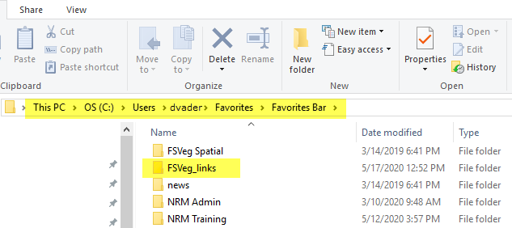
- Contents of FSVeg_links: MANY OF THESE WON’T WORK IN GOOGLE CHROME; USE Microsoft Edge ONLY! If Chrome opens when you click one of them, just copy the URL in Chrome, then open a Microsoft Edge window and paste the copied URL into it.
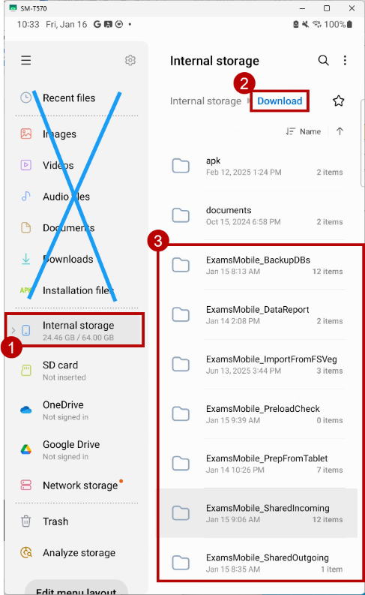
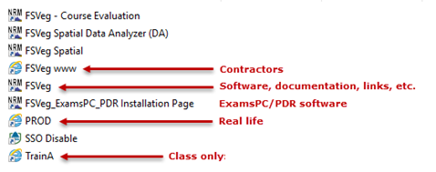
- Observe on your tablet that the following folders will be created under
Internal Storage > Download after installing Exams Mobile:
- ExamsMobile_BackupDBs – created when you run the tool
- ExamsMobile_DataReport – created when you run the tool
- ExamsMobile_ImportFromFSVeg
- ExamsMobile_PreloadCheck – created when you run the tool
- ExamsMobile_PrepFromTablet
- ExamsMobile_SharedIncoming – some pre-built content has been added to this in class
- ExamsMobile_SharedOutgoing
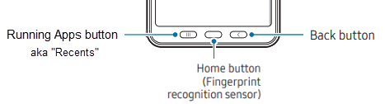
- Decoding the Tablet Buttons of Mystery:
Used to switch between running apps
Cancel, return to a previous form, or hide the keyboard
- Class Materials / copy these folders to the C drive.zip
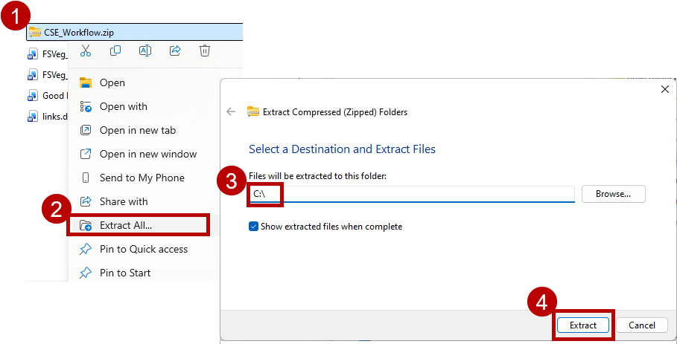
Unzip and save the contents of copy these folders to the C drive:
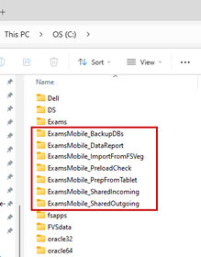

Topic B: Install Exams Mobile from Google Play
On the Android 11 or later tablet (Exams Mobile won’t run properly on earlier Android versions or phones, or on iOS):
- WiFi-only tablets: Connect to a network (If you don’t have Exams Mobile on your tablet, you can skip to Step 4.)
- Backup Exams DB since uninstalling Exams Mobile will delete all data files and personal templates.
- Uninstall any previous version of Exams Mobile on your tablet:
  - Tap and hold on the Exams Mobile icon.
  - Uninstall
- Download and Install Exams Mobile:
- Open Google Play on your Android tablet
- Search for “FSVeg Exams Mobile”
- Select the FSVeg Exams Mobile item
- If you were a beta tester for Exams Mobile, the page that opens will be labelled FSVeg Exams Mobile (Beta) – that’s just because you are listed as a beta tester in Google Play. To get to the production version, you need to remove yourself from the beta tester roster. Scroll down to the You’re a beta tester section, then select Leave. The next time you visit this page, the beta designation will be removed. You can always reinstate yourself as a beta tester for Exams Mobile in the future if needed.
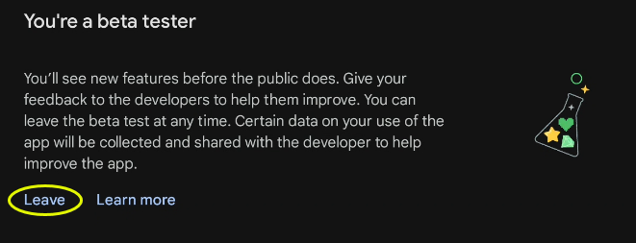
- Install and Open (Note: If you have the Update option instead of Install, it means you haven’t uninstalled the prior version – go back and complete steps 2 and 3, above. Never, ever choose Update; it will mess things up on your tablet, but it won’t be evident until you’re in the woods trying to collect data.)
The Exams Mobile installation includes both the app itself and its SQLite database that is preloaded with the Regional Templates with their associated User Definitions, Field Selections, and Default Sample Designs.
How to tell if you have a prior version of Exams Mobile on your tablet:

You have a prior version when Google Play does this: You don’t have a prior version; you can proceed:
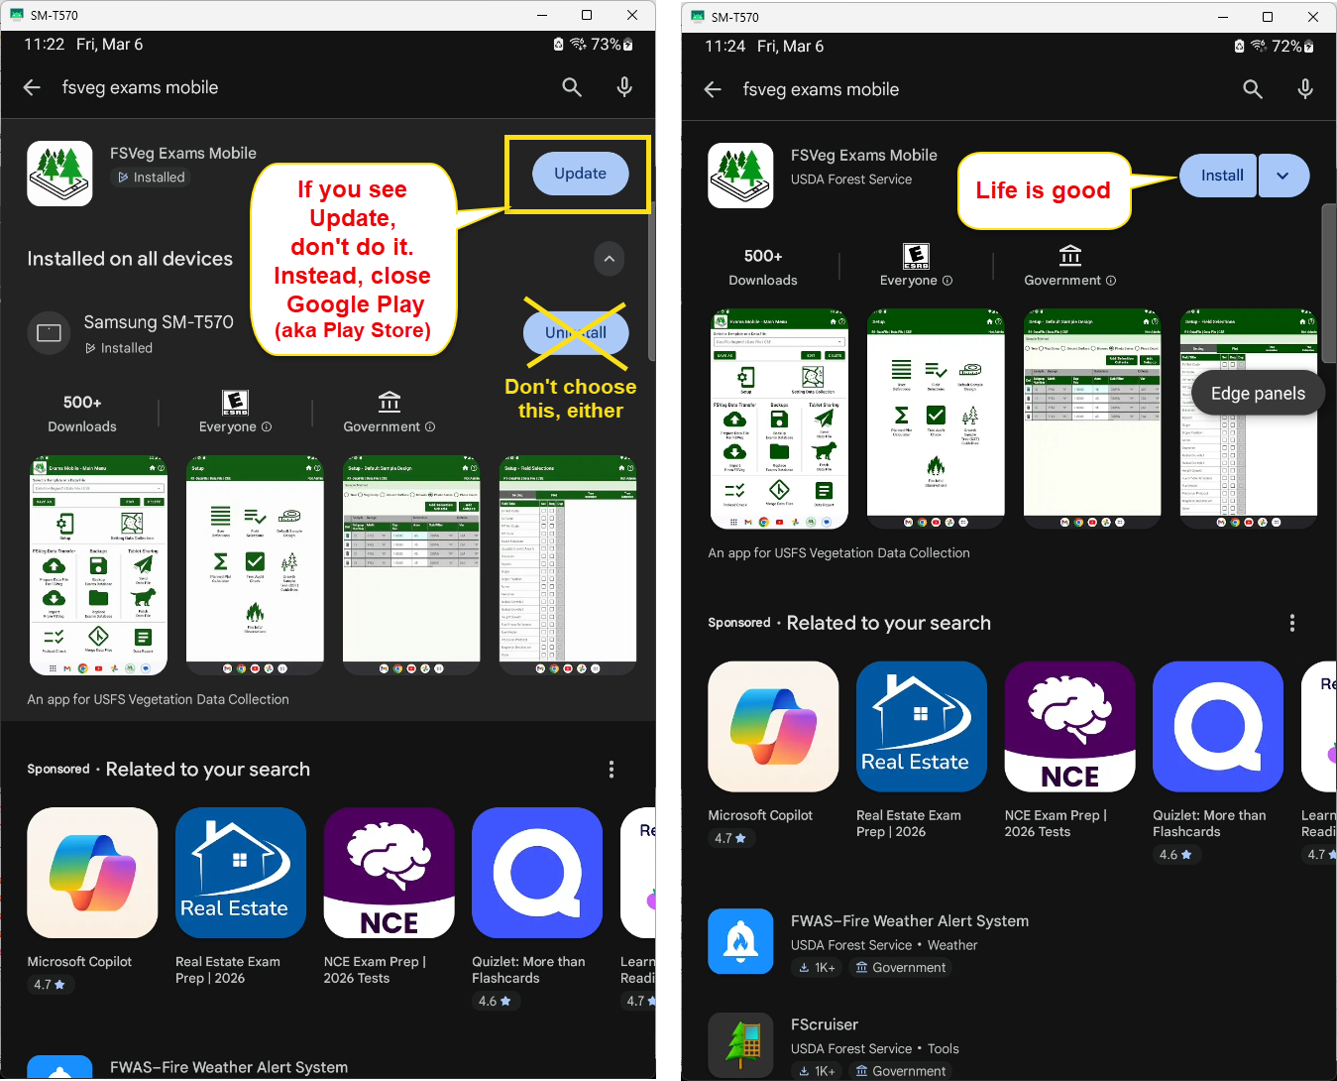

Topic C: Overview of the typical workflow:
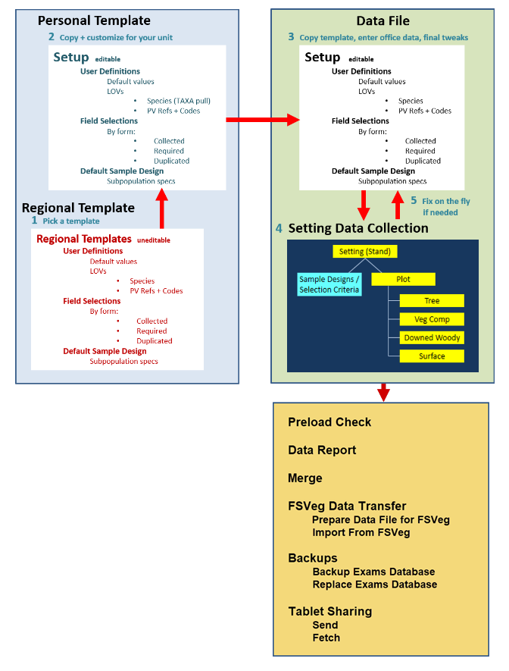
Topic D: Setup – Create a Personal Template from a Regional Template
NOTE: For this class, we will act as if we are all employees of the one forest we are using for training this week; however, when you return to your home unit, you will use the values for that unit.
Purpose: Create a Personal Template.
- Main Menu > Select a Template or a Data File
  - Regional Templates > R3_template.cse | Regional Template | CSE
- Save As
  - Apache-Sitgreaves CSE
    - Personal Template
    - CSE
    - Save

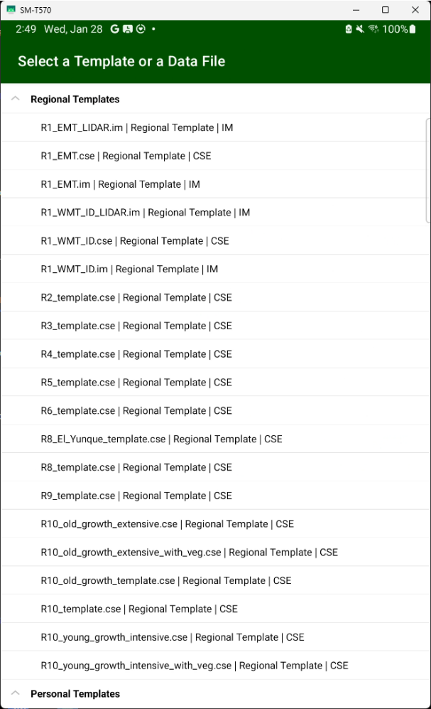
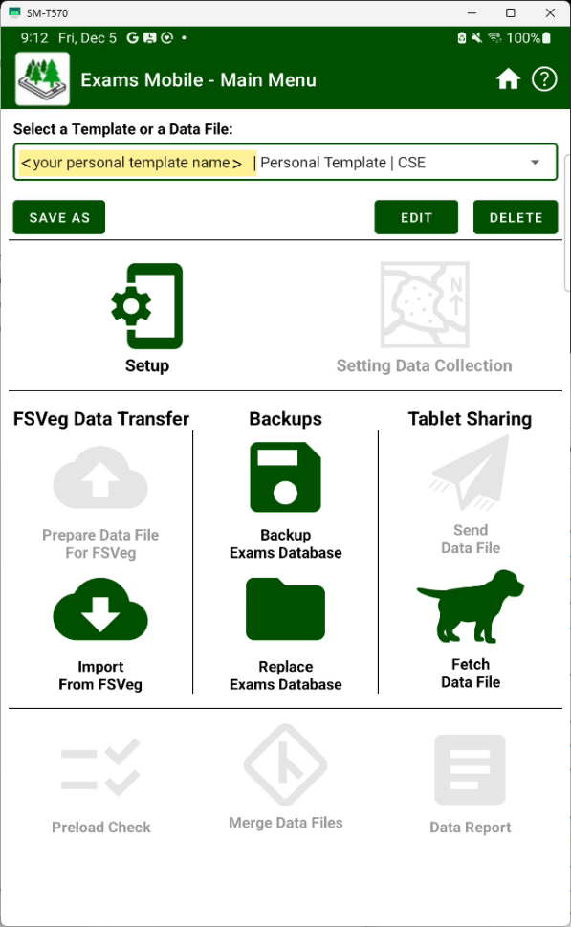
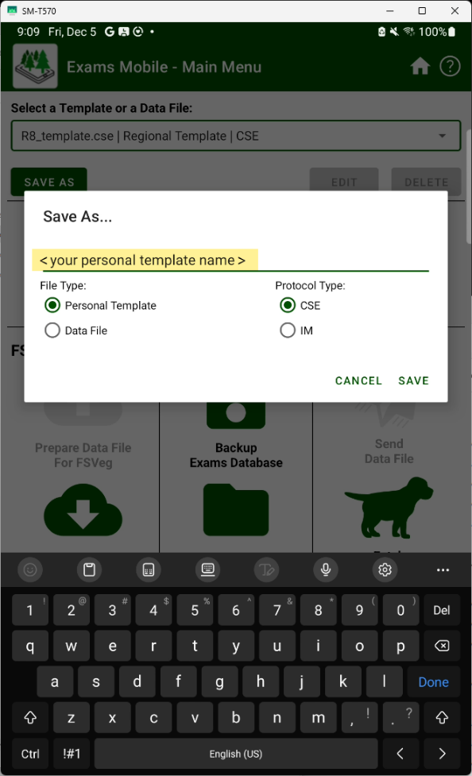
Topic E: Setup > User Definitions – Customize your Personal Template
Purpose: Configure the Personal Template to save time and effort while reducing errors in the field:
- Identify values that will be populated by default whenever you create a new setting (i.e., stand exam).
- Define Lists of Values (LOV) for data (such as Project Name, Location, Exam Level, EV & PV References, Examiner, Tree Species, and so on).
Tasks:
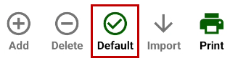
- Personal Template’s name is showing in the Select box.
- Setup > User Definitions – Set the following values as Default by using the Default button:
- Make sure (Default) appears, or the desired values won’t autopopulate in the forms:
The reason Existing Veg Reference/Codes, Potential Veg Reference/Codes, and Fuel Photo Reference/Residue Description Codes have 3 or 4 options each is because the old equipment and software made it difficult to easily switch between different references and their codes. So, this solution was created to give people a way to have a few different options to choose from when moving to the next stand. Even though we no longer have the original limitations, it’s still a convenient way to have your most common references and their codes identified ahead of time and ready for use, so we retained this feature for Exams Mobile.
Admin Region | 03 Southwestern Region
Admin Forest | 0301 Apache-Sitgreaves  In reality, the admin forest is the last two digits; the fact that it displays region and forest is a software thing
Proc Region | 03 Southwestern Region
Proc Forest | 0311 Sitgreaves
Ranger District | 031102 Black Mesa
Location | 009898 – Make this the default value with a description of: classroom
Project Names | CSE CLASS (if your training includes a field session, make this the default value)  Hint: Be really careful typing in entries such as Project Name. Notice that the one, above:  1. Uses all capitals  2. Has a space separating the words  To a computer, ‘CSE CLASS’, ‘CSE Class’, ‘CSECLASS’, ‘cse class’, and so on are all different project names!
Ownership | USFS
State | AZ
County | 03_AZ_017 Navajo
Examination Levels | 3221  Tree = 3 Intensive Plot  Veg Comp = 2 TES, NOX  Downed Woody = 2 Brown’s Protocol  Surface Cover = 1 Collected
Purpose Code | SE
Stratum | Code = YOO Description = Year of Origin Stratum differs from most other LOVs in that you don’t have to populate the list here. So the default value ‘YOO’ will appear in this field, reminding you what it’s for in this case.
Existing Veg Ref (A) | SAF Society of American Foresters
Existing Veg Codes (A) | Populate this list by tapping on it to open it – otherwise, they won’t appear in the Setting or Plot Forms (It’s a known bug that we can’t fix yet)
Potential Veg Ref (C) | 301 Plant Associations of AZ and NM etc.
Potential Veg Codes (C) | Populate this list by tapping on it to open it – otherwise, they won’t appear in the Setting or Plot Forms (It’s a known bug that we can’t fix yet)
Examiner | your initials or last name – don’t enter your whole name (PII concerns)
Plot User Field | 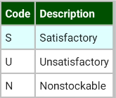  Add these codes and descriptions:  You cannot use User Fields unless  These are just examples from a stocking survey to illustrate how user fields can work for your purposes – you wouldn’t necessarily use these specific values in a typical stand exam.  They are defined ahead of time
Tree User Field | 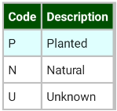  Add these codes and descriptions:  You cannot use User Fields unless  They are defined ahead of time

Spp of Mgt Interest | Do this: Use It? = No | Whenever creating a new Personal Template from a Regional Template, do these weird steps:  - Turn off all Spp of Mgt Interest  - Turn off, then on, all Tree Spp  - Turn off, then on, all Veg Spp  Doing so will ensure that only Spp of Mgt Interest that are in your Forest’s Tree and Veg species lists will be set to Use It? = Yes
Tree Species | Do the following:  - Use It? = No  - Use It? = Yes  - Then trim your species list
Veg Species | Do the following:  - Use It? = No  - Use It? = Yes  - Then trim your species list
Spp. Of Mgt Interest is a Regional list – you need to turn off all but the ones that occur on your forest by following these steps:

Caveat for Region 5: The 3 species lists are very long, and as a result (1) it can take a while to populate each list and (2) you may get a popup message giving you the option to either shut down the app or wait until it’s done – you can actually disregard this popup by selecting the wait option and moving on to the next item. Although it will continue to appear periodically, it will eventually stop doing so.

This turning off and on of species is to enable only the species of management interest that occur on your forest:
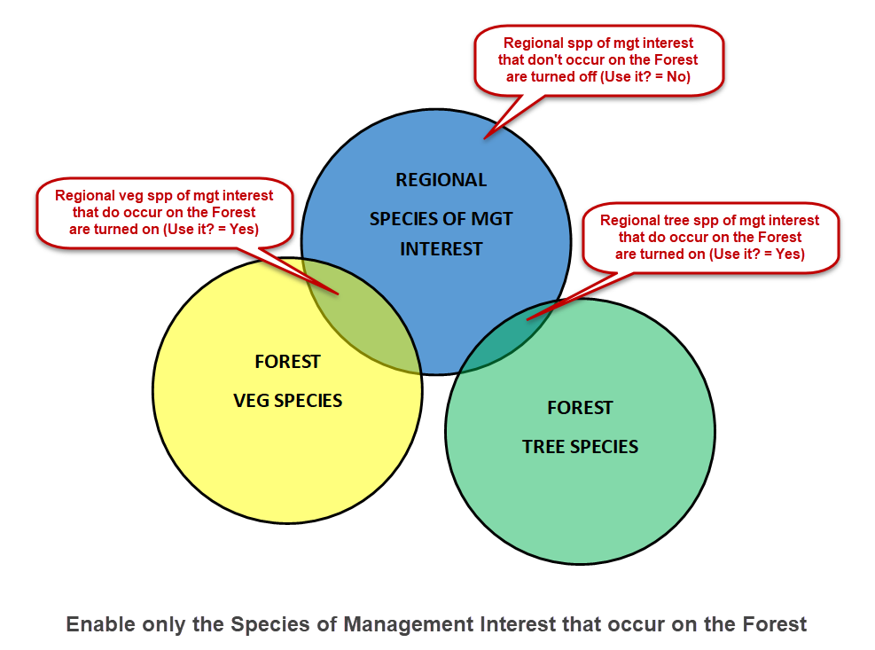
For attributes that have the Print button enabled, you can create a .txt file of the list contents saved to:
Internal storage > Download

Topic F: Setup > Field Selections – Customize your Personal Template
Look over the field selections – remember, these were copied from the Regional template; your home unit may opt to collect more (or less) information.
Pay special attention to the intensity of the Tree tabs – there’s 3 different intensities!
There are five data areas to consider:
- Setting – We can now customize the Setting Form! Make sure you select the following (uncheck all the others):

  - EV Ref Code
  - EV Code
  - PV Ref Code
  - PV Code
  - Stand Structure
  - Capable Growth Area %
  - Elevation
  - Aspect
  - Slope

  - Acres
  - Examiner
  - Radial Growth 1
  - Height Growth
  - Fuel Model
  - State
  - County
  - Latitude/Longitude Datum
  - Stratum (can be used as a 6-character wild card; our class will use it for Year of Origin, YOO)

- Plot – Select the following:

- Latitude
- Longitude
- Capable Growth Area %
- Aspect
- Slope
- Elevation
- Existing Vegetation
- Potential Vegetation
- Fuel Model
- User Defined Field (a 4-character wild card; our class will use it for Plot Stocking Class)

In the real world, look on your unit; consider what is typically collected and why. For example:
  - Potential Vegetation
  - Fuel Model: Classify the plot as one of the fuel models (1-13 or 91-204).
  - Residue Descriptive Code: Using the fuel photo reference recorded on the CSE Setting Form, identify the photo (by its residue descriptive code) that most closely represents the fuel conditions on the plot.
- Tree, Intensive: Make sure you select the correct intensity tab before making further field selections
- Log/Snag Decay Class
- DRC Spec. (# of Stems)
- User Defined Field (a 4-character wild card; our class will use it for Planted/Natural)
- Remarks
Note that Dup is selected, but this function does not currently work; un-check it.
- Veg Comp – Protocols:
i. Cover by Lifeform (un-check all Optional Lifeforms and User Defined Field)
ii. Cover by Species and Layer
iii. Cover by Species (check Use this Form and un-check User-Defined Field)
- Downed Woody – 3 possible protocols: Brown’s, Piece Count, Photo Ocular.
  - Make sure Piece Length, Small End Diameter, and Large End Diameter are checked, because piece length enables pieces/acre computations and small end diameter may be needed for habitat analysis.
Topic G: Setup > Default Sample Design – Customize your Personal Template
The Default Sample Design will be automatically applied to every new setting you create in the Setting Data Collection tool. You can customize the Default Sample Design to your unit’s resource conditions and analysis needs.
A. Tree data is collected using both variable (BAF) and fixed (FRQ) radius plots:
10 BAF plot to survey live standing trees with a DBH of 5.00 inches and larger
10 BAF plot to survey live standing trees with a DRC of 3.00 inches and larger
1/100th ac plot to survey live standing trees with a DBH of 0.01 to 4.99 inches DBH
1/100th ac plot to survey live standing DBH trees with a HGT of 0.5 to 4.49 feet
1/100th ac plot to survey live standing trees with a DRC of 0.01 to 2.99 inches DBH
1/2 ac plot to survey dead standing trees where DBH >= 5 in AND HGT >= 10
1/2 ac plot to survey dead standing trees where DRC >= 5 in AND HGT >= 10

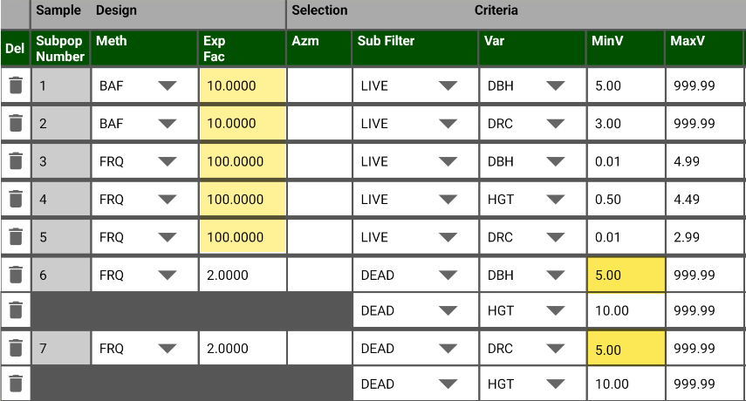
B. Veg Composition data is collected using a fixed-area plot:
1/100th acre plot to survey live vegetation with a canopy cover >= 0.5% or more
Subpop var = CVR
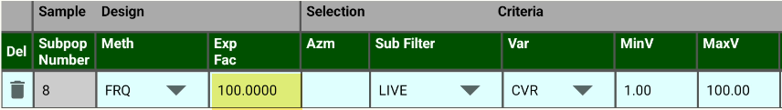
C. Surface Cover data is collected using a fixed-radius plot:
1/100th acre plot to survey features that intersect the ground surface with a cover of 1% or more. Subpop var = SVC
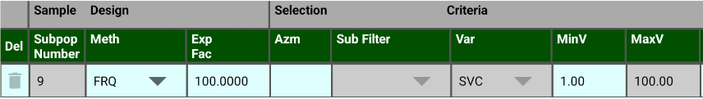
D. Downed Woody data collected using a Brown’s planar transect:
7 foot transect for all pieces with an INTERSECTION diameter of .01-.24”
7 foot transect for all pieces with an INTERSECTION diameter of .25- .99”
14 foot transect for all pieces with an INTERSECTION diameter of 1.0-2.99”
75 foot transect for all pieces with an INTERSECTION diameter of 3.00” or greater

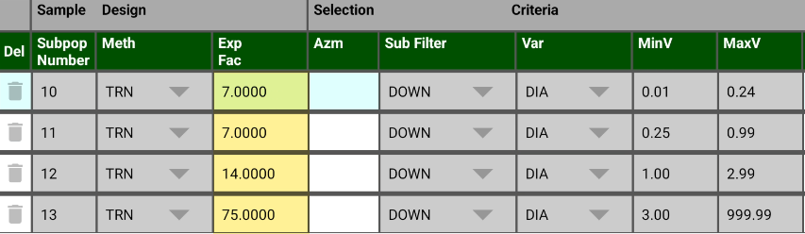


The values in the default sample design will be automatically copied to new stand exams you create after saving it. It won’t affect stand exams that already exist in Exams Mobile.
For example, suppose you already have an exam for stand 4501, where large live trees are sampled using a BAF 40. Then you change the default sample design so that large live trees are sampled with a BAF 20 and create exams for stands 4502 and 4503. Then you change the default sample design so that large live trees are sampled using a BAF 10 and create exams for stands 4504 and 4505. The net result of these actions is that the expansion factors for the large live trees in these stand exams are:
Day | Stand | BAF
Tuesday | 4501 | 40
Setup > Default Sample Designs: You change the BAF to 20
This doesn’t affect Stand 4501 (BAF 40)
Thursday | 4502 | 20
 | 4503 | 20
Setup > Default Sample Designs: You change the BAF to 10
This doesn’t affect Stand 4501 (BAF 40), 4502 + 4503 (BAF 20)
Friday | 4504 | 10
 | 4505 | 10

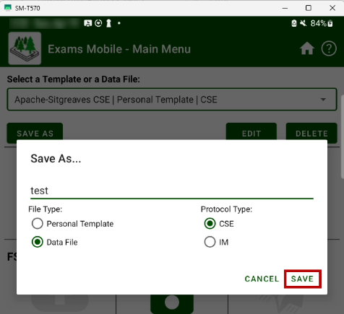

Mini-Topic 1: Test your Personal Template:
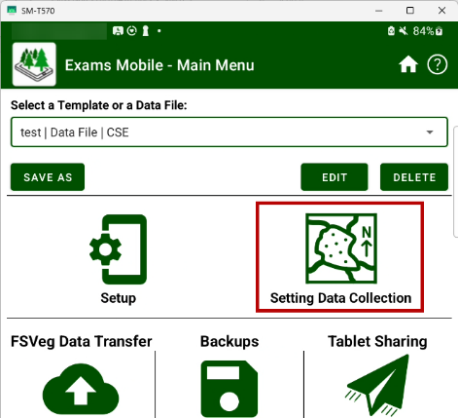
      - Save As
        - Data File
        - Give it a short name, such as “test”
        - Save
      - Setting Data Collection
        - Add Setting
        - Enter a dummy Stand value, such as 0012
        - Check:
          - Selected fields are displayed
          - Unselected fields are not displayed
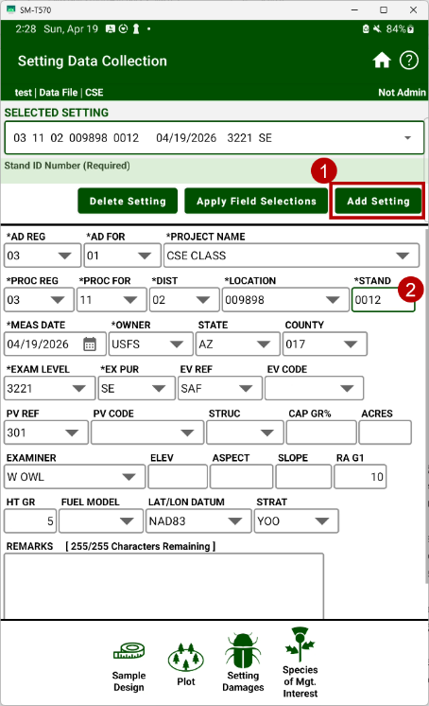
          - Default values are populated
          - Lists of values (LOVs) have values:
            - Locations
            - Project Names
            - EV and PV Codes (if used)
            - User Defined codes (if used)
          - Make sure you check each form:
            - Setting
            - Sample Designs
            - Plot
            - Tree
            - Veg Comp / Surface Cover
            - Downed Woody

Mini-Topic 2: Backup your Personal Template:
- Backups > Backup Exams Database
- Give it a distinctive name; add “template” to the end (such as “Apache-Sitgreaves CSE backup”)
- Backup
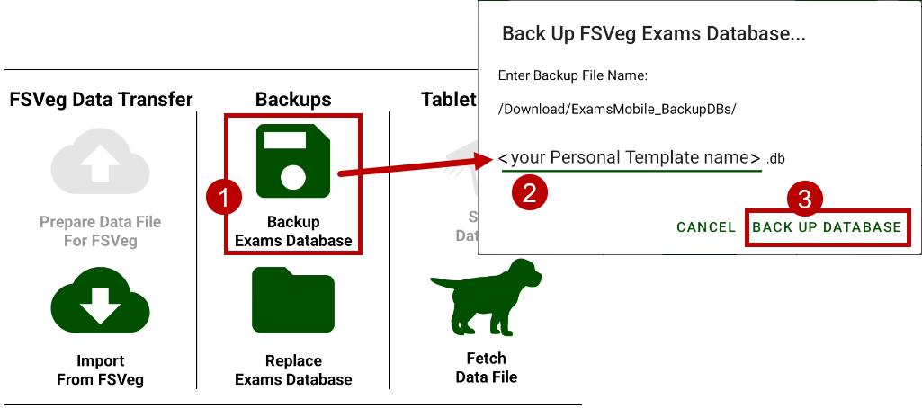
A Backup DB is the way to distribute your Personal Template to your crew, contractors, etc.


Topic H: Create your Data File from your Personal Template
- Main Menu (Home button )
- Select: <your Personal Template name> | Personal Template | CSE
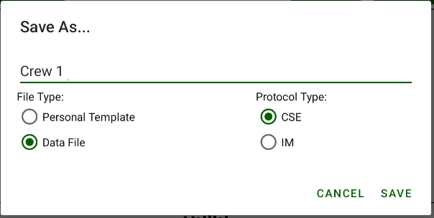
- Save As
  - Crew 1
  - Data File
  - CSE
  - Save

Notice that we’re no longer working with Regional or Personal Templates; from now on, we’re working with our Data File:
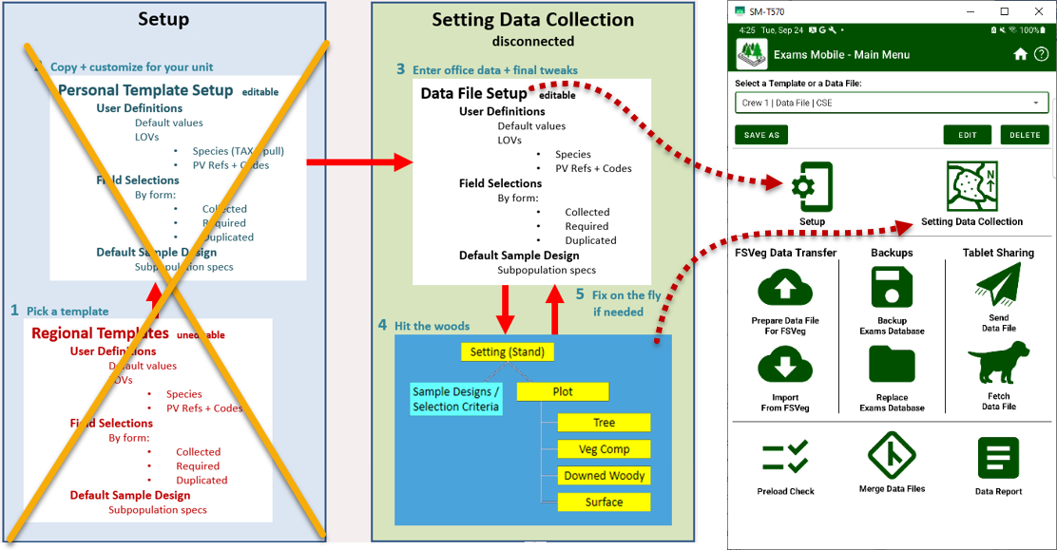

Because we’re now working with our Data File:
      - The Data File name appears in the Selected box.
      - The Data File contains two parts:
        - Setup (User Definitions, Field Selections, and Default Sample Design) that were copied from your Personal Template, but you can modify them further as needed.
        - Data Collection – where you will enter your stand exam data.
      - Note: Data Files can hold multiple stand exams. As a result, you have a lot of flexibility to group or separate your stand exams in ways that make the most sense to you.

Topic I: Setting Data Collection: Create stand exams in your data file and enter pre-survey data (Setting & Sample Designs)
You will create two stand exams; one that you will use in the office exercise (xx01), and one that you will use in the “field exercise” (xx02), where xx is your Student ID for the class. Your ID, xx =
Example: If your Student ID is 15, then your two stands will be 1501 and 1502
1. Create 2 stand exams in your data file by entering “pre-survey” (items that can be entered in the office) setting data for them.
A. Select Crew 1 | Data File | CSE
- Main Menu > Setting Data Collection
- Notice that SELECTED SETTING is blank – because you don’t have any settings in the Data File yet.
- Add Setting
Notice that the default values that you set earlier will be entered for you in the Setting form (if you forgot to designate default values, go to Setup > User Definitions and set them to default, then navigate back here). Because the default values are entered for you onto the Setting form, all you have to do is (1) check that they’re correct and (2) enter the following setting-specific data:
Item | Setting xx01 | Setting xx02
Stand ID (4 digits) | xx01 | xx02
Measurement Date | today’s date | today’s date
Acres | 37 acres | 46 acres
Examiner (15 digits) | your initials | your initials
First Radial Growth Interval | 10 years | 10 years
Height Growth Interval | 5 years | 5 years
Fuel Photo Reference | Pick one used on your home unit | Pick one used on your home unit
There will be some setting data that you won’t be able to enter until after you’ve seen the stand (“post-survey”).
2. Check and modify, if needed, the sample design data for both settings/stand exams
A. Sample Design
Make certain that the sample designs match what you intend to sample in the stand (for this exercise, compare the values with the ones shown in Exercise F, above).
Everything here is important – they’re used to uniquely specify your subpopulations of interest (see Appendix 7 of this CSE Workflow), link tree etc. records to the appropriate subpopulation specifications, and generate the correct expansion TPA and BA/ac expansions, but pay special attention to expansion factors and selection methods.
Remember, you are now editing the Setting’s sample design – not the Setup > Default Sample Design that gets applied to newly created settings in this Data File. Any edits you make to this setting’s sample design affect only this one setting to which it belongs – and your edits to this setting’s sample design won’t affect other settings’ sample design in the Data File.

Get into the habit of checking the dark and light green banners at the top of the screen; they will tell you what you’re working with, whether it’s a template or data file, and under IM or CSWE protocol. If you’re in Setting Data Collection, it will identify the setting, plot, tree, and so on. If you’re in Setup, it will tell you whether you’re working with a template or data files (an important distinction).

Topic J: Enter Stand xx01 Plot 1 (you may ignore the shaded items)
You’ve just hiked to the first plot. Use the Plot icon at the bottom of the Setting form to navigate to the Plot form. Use the Add Plot Record button to create a new plot record.
Note:
The Help and Option buttons can be very helpful when entering data.
Latitude | If the signal permits, use the tablet’s GPS to acquire the values
Longitude | If the signal permits, use the tablet’s GPS to acquire the values
Capable grow % | 95
Aspect | 183
Slope | 15
Elevation | 6842
Existing Veg. | interior ponderosa pine (237)
Potential Veg. | ponderosa pine/screwleaf muhly-Arizona fescue (011390)
Fuel Model | Timber (litter and understory) (10)
UserDefCode | Satisfactory (S)
Remarks | Root rot seen off-plot. Rock outcrop near plot to SW.
Plot History, History Date | Clear cut (15), 1872
Plot History, History Date | Improvement Cut (21), 1998
Plot History, History Date | Fire (6), 2010

Topic K: Enter Stand xx01 Plot 1 Downed Woody Material, Veg Comp, Ground Surface Cover
Plot Data/Down Woody Material Data, Veg. Composition|Ground Surface Cover Data
1. Downed Woody Material – Brown’s Transect
• 1st duff measurement is 3 inches (Duf1)
• 2nd duff measurement is 5 inches (Duf2)
• Total fuel depth is 27 inches (FuD)
• There are 11 pieces in the .01-.24 inch category (1-HR)
• There are 8 pieces in the .25-.99 inch category (10-HR)
• There are 3 pieces in the 1.0-2.99 inch category (100-HR)
• Coarse Woody Debris (3+” aka 1000-HR) is as follows:
Piece Count | Decay Class | Diameter | Length | Small End Diameter | Large-End Diameter
1 | 3 | 11 | 14 | 8 | 22
1 | 3 | 10 | 23 | 6 | 18
1 | 4 | 14 | 7 | 11 | 17
1 | 3 | 6 | 9 | 4 | 13
1 | 5 | 27 | 42 | 5 | 34
1 | 1 | 4 | 6 | 3 | 8
1 | 2 | 8 | 12 | 6 | 14

Note: We collect the length so that we can compute pieces/acre; we collect the small end diameter because size criteria in most forest plans specify minimum diameter.

- Veg Composition and Surface Cover - Obtain the canopy cover occupied by the vegetation components of interest. FYI, most surveys collect just the first tab – but whether you collect one or all the tabs depends on the purpose of your stand exam. Canopy cover is measured as the cumulative vertical projection of the canopy onto the ground, by:
  - Lifeform (1st tab)
  - Species and Layer (2nd tab)
  - Species (3rd tab)
Keep in mind:
  - It’s as if you were viewing the plot from directly above (vertical projection of canopy dripline onto the ground).
  - Treat each layer independently of the other layers, for example:

    - TOT – All Trees: 75% canopy cover

    - TOV – Overstory Trees (Hgt >= 6.1 ft): 60% canopy cover

    - TSA – Understory Trees (1.6 ft <= Hgt <= 6.0 ft): 10% canopy cover

There are 2 different ways to do this:
- Ocular estimate (by eye). Given how subjective this can be, this aid may help:
A circle with 1/10th the diameter of the plot is 1/100th of the plot area:
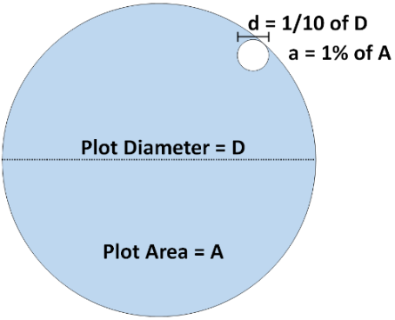

Plot | Plot Radius | Plot: Diameter | 1% Area: Radius | 1% Area: Diameter
1/10 ac | 37.2’ | 74.47’ | 3.72’ | 7.45’
1/100 ac | 11.78’ | 23.55’ | 1.18’ | 2.36’
1/300 ac | 6.80’ | 13.60’ | 0.68’ | 1.36’

For anything heavily reliant on subjective judgement, it’s a good idea to meet with your crew/contractors in the field to get everyone on the same page before any data are collected for real.
- Linear transect:
    - Lay out a 100’ transect.
    - Tally vegetation (e.g., grass, tall tree, medium shrub, etc.) at each foot.
    - Convert tally by vegetation to % cover.
Enter the following Vegetation Composition data for this exercise:
Cover by Lifeform (1st tab):
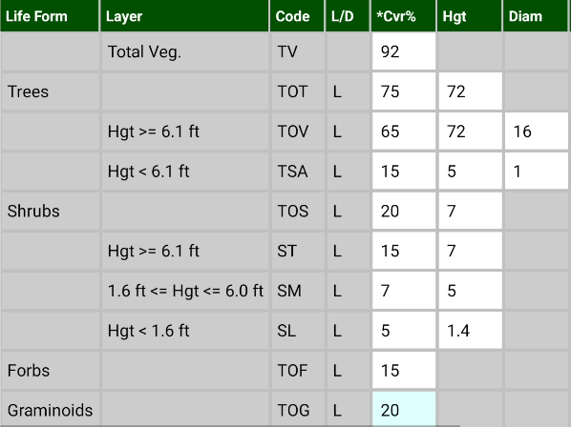

Cover by Species (3rd tab):
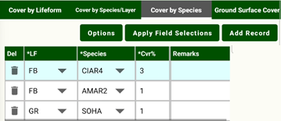

Ground Surface Cover (4th tab) – Surface cover is different from canopy cover; instead, we are trying to get an estimate of how much of a plane at the ground surface is occupied by different items. So for any type of vegetation, we are looking at the cumulative cross-sectional areas at the ground surface, and it’s a lot less than you would guess at first. For example, it’s estimated that in the densest tropical jungle, basal vegetation (BAVE) usually doesn’t go much above 15%.
Enter the following Surface Cover data for this exercise:

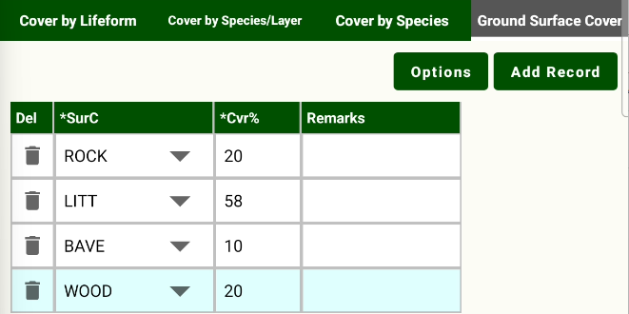

Surface cover must add up to 100%, so you must adjust if it doesn’t (it’s different than Veg Comp)

Topic L: Stand xx01 Plot 1 Trees
Tag ID | Tree Status (T) | Site/Growth (S) | Species | Tree Count (TCnt) | DRC # of Stems | DBH/DRC* | Height (Hgt) | Radial Growth (RaG1) | Height Growth (HgtG) | Age | Crown Ratio (Crat) | Log/Snag Decay Class (LS) | User Defined Field | Damage - Look up and enter the category, agent, tree part, and severity corresponding to these descriptions
1 | D |  | PIPO | 1 |  | 11.3 | 37 |  |  |  |  | 1 |  | broken top, sev 30%, top (99/001/30/TO)  Wildfire, sev 1, Base (30/031/1/BA)
2 | D |  | PIPO | 1 |  | 19.8 | 51 |  |  |  |  | 3 |  | crook/sweep, sev 15%, bole (99/006/15/BO)  western dwarf mistletoe, DMR 3, mid 1/3 (23/008/3/MT)
3 | L | Both | PIPO | 1 |  | 15.1 | 85 | 15 |  | 68 | 40 |  |  | Western pine beetle, sev 1, bole (11/002/1/BO)
4 | L | GST | QUGA | 1 | 3 | 1.2, 4.8, 3.6 | 32 | 10 |  | 35 | 85
5 | L | GST | JUDE2 | 1 | 2 | 11.8, 8.6 | 56 | 8 |  | 55 | 70
6 | L |  | JUDE2 | 1 | 1 | 4.2 | 13 |  |  |  | 40
7 | L | GST | PIPO | 1 |  |  | 4 |  | 1.2 | 5 | 50 |  |  | crook/sweep, 15%, bole (99/006/15/BO)
8 | L |  | PIPO | 1 |  |  | 3 |  |  |  | 70 |  | N
9 | L |  | PIPO | 5 |  | 2.7 | 12 |  |  |  | 85 |  | N
10** | D |  | QUGA | 1 | 1 | 2.2 | 3 |  |  |  |  | 4 | U | Are you sure about this? See subpops
Plot - Tree Data

**Should you really sample this tree? Look at the sample designs.
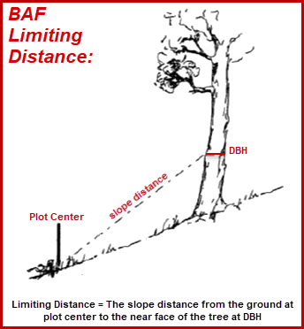
The Options button on the Tree form gives you access to several useful tools:
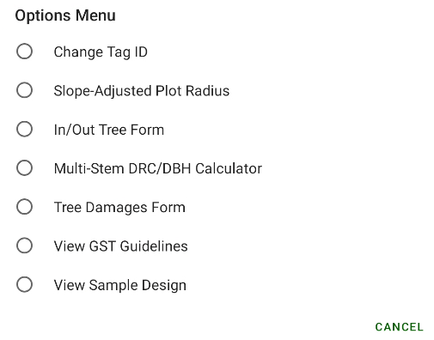
slope
and
1. Change Tag ID: Particularly useful when merging separate plots of one stand exam that were collected by two or more crews – especially when one considers that the Merge tool will not automatically re-number plots.
2. Slope-Adjusted Plot Radius: Fixed-area plot radius (in horizontal distance and slope distance) is computed from the inverse of the plot size and the slope. Does not pull plot size from Sample Designs.
3. In|Out Tree Form: Enter the diameter, the slope distance from the pin to the face at DBH, and the slope (also from the pin to the face at DBH) to determine if the tree is in or out. Notice that it uses the BAF from the sample design (but check it) and will also provide a limiting distance and limiting slope distance. If the tree is in, the diameter will be automatically placed in the tree form. This consistently gets voted as the “Coolest Thing since the Relaskop” at FSVeg/CSE classes.
4. Multi-Stem DRC/DBH Calculator: Enter the diameters of the individual stems of a multi-stemmed tree to quickly compute its effective DRC.
5. Tree Damage Form: Access a tree’s damages either from the Damage field (click in the D field, then select Form) or you can choose this option.
6. View GST Guidelines: Let’s face it; these can get confusing sometimes, especially after getting hit by a bunch of marble-sized hailstones.

7. View Sample Design: In case you forget. After dodging that moose back at plot 4.
Plot 1 On-the-Fly Repairs:
Apply Field Selections: Suppose you made it all the way to the first plot when you suddenly realize that you made an epic mistake with your field selections when setting things up, such as forgetting to include a really important field. You can fix the situation by doing this:
A. Enter required fields for all trees (or the form won’t let you leave)
B. Return to the Main Menu.
C. Setup > Field Selections, then set them up as they should be.
D. When you get back to the tree form complete the repair: Apply Field Selections
Try it by adding Crown Width – see if it shows up on the Tree form.
Setting Sample Designs: Another fix you can make on Plot 1 is to correct Setting Sample Designs. For instance, changing BAF or FRQ expansion factors to reflect the actual density of trees.
Preload Check: Run it on every plot, while you’re still there. Fix measurement typos, remove trees that shouldn’t have been sampled, and fix bad sample designs.

Topic M: Enter Stand xx01 Plot 2

Latitude | If the signal permits, use the tablet’s GPS to acquire the values
Longitude | If the signal permits, use the tablet’s GPS to acquire the values
Capable grow % | 85
Aspect | 242
Slope | 27
Elevation | 6912
Existing Veg. | interior ponderosa pine (237)
Potential Veg. | ponderosa pine/screwleaf muhly-Arizona fescue (011390)
Fuel Model | Timber (grass and understory) (2)
UserDefCode | Satisfactory (S)
Remarks | Seep to N at base of talus slope. Game trails.
Plot History, History Date | Fire (6), 2023
Plot History, History Date | Animal Damage (12), 2002

Topic N: Enter Stand xx01 Plot 2 Downed Woody Material, Veg Comp, Ground Surface Cover
          - Downed woody material was not found on plot number 2.
This is REALLY different from the situation where it is not sampled.
When this happens for any type of data (tree, veg comp, downed woody, surface cover), it’s a good idea to make a note of it in the Plot Remarks for the plot on which it occurred to prevent anyone from thinking that you may have simply forgotten to collect that part of the data (e.g., “DW sampled but recent fire eliminated all material”).
2. Veg Composition and Surface Cover
Cover by Lifeform (1st tab):
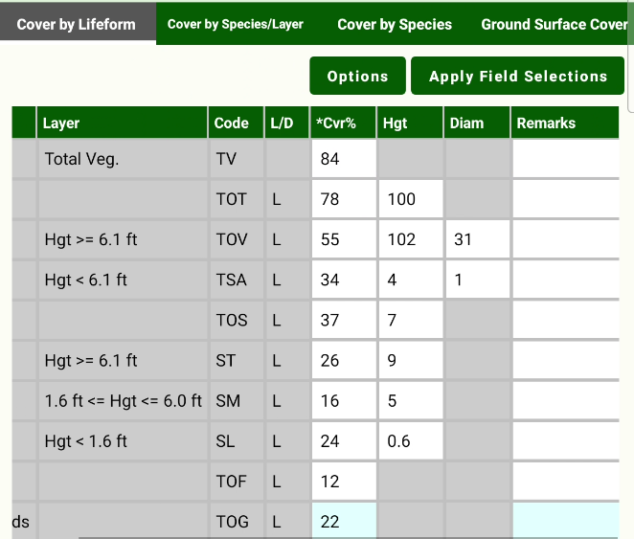
Cover by Species (3rd tab):
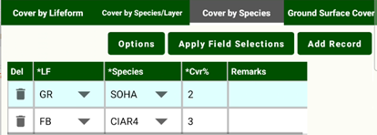

Ground Surface Cover (4th tab):

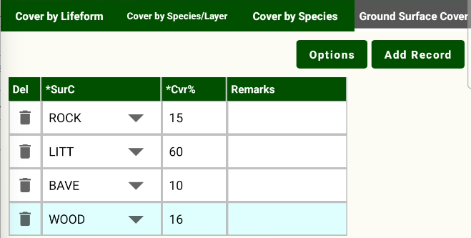

Note that surface cover doesn’t add up to 100% so you must adjust for that.

Topic O: Enter Stand xx01 Plot 2 Trees
Tag ID | Tree Status (T) | Site/Growth (S) | Species | Tree Count | DRC # of Stems | DBH/DRC* | Height (Hgt) | Radial Growth (RaG1) | Height Growth (HgtG) | Age | Crown Ratio (Crat) | Log/Snag Decay Class (LS) | User Defined Field | Damage (D)
1 | L | Both | PIPO | 1 |  | 20.9 | 74 | 8 |  | 56 | 45
2 | L |  | PIPO | 1 |  | 21.3 | 81 |  |  |  | 35 |  |  | heart rot, severity 3, bole (22/001/3/BO)
3 | L | GST | QUGA | 1 | 2 | 5.7, 8.3 | 16 | 2 |  | 78 | 80
4 | L | Both | JUDE2 | 1 | 3 | 12.4,3.2, 6.4 | 79 | 6 |  | 95 | 50
5 | D |  | PIPO | 1 |  | 22.2 | 79 |  |  |  |  | 1 |  | broken top, sev 10%, top (99/001/10/TO)
6 | L |  | PIPO | 1 |  | 4.8 | 19 |  |  |  | 80
7 | L |  | JUDE2 | 1 | 2 | 2.8, 3.7 | 8 |  |  |  | 50 |  | N
8 | L |  | PIPO | 1 |  |  | 3 |  |  |  | 75 |  | N
9 | L | GST | JUDE2 | 3 | 1 | 2.6 | 6 |  | 3.6 | 5 | 80 |  | N

Topic P: Enter post-survey setting data for setting xx01
Setting Data Collection
You’ve just completed the last plot in Setting 1 and have a pretty good idea of what the stand is all about.
Now you’re ready to finish entering setting data for Setting 1 based on your recent observations:
Item | Setting xx01
Existing Veg | interior ponderosa pine (237)
Potential Veg. | ponderosa pine/screwleaf muhly-Arizona fescue (011390)
Stand Structure | Multi-storied (MS)
Capable Growth Area % | 87
Elevation* | 6890
Aspect* | 206 degrees
Slope* | 30%
Fuel Model | timber (litter and understory) (10)
Stratum (YOO) | 1936
Remarks  Comments to aid writing an Rx | Seeps, surface rock, and Armillaria pockets in stand. Leafy spurge along road. Thistle in old openings.
Setting Damages  Seen in the stand but not on the plots | Armillaria, Sev 4, Both crown and diagnostic signs/symptoms detected (21/001/4)  Domestic cattle, minor (42/001/1))
Species of Mgt Interest  Seen in the stand but not on the plots | Johnson grass (SOHA )  Canadian thistle (CIAR4)  leafy spurge (EUES)
*If collected, this data is taken on each plot and then manually summarized on the Setting Form after all plots have been sampled.

Topic Q: Collect data for setting xx02 (aka the “Field Exercise”)
The scenario: You’ve prepped your tablet for Setting 2 in the office (remember, you did this in Exercise 1), and now you’re in the woods to conduct the stand exam. Your analysis for this exercise only requires tree information, so you won’t collect veg comp, surface cover, or downed woody data.
For this exercise, please do the following:

Not used for this class
- Group up in teams of at least 2 people, depending on the availability of tablets.
- We will spend a day in the field to discuss the techniques used to collect stand exam data (a brief outline is presented in Appendix 6). As we do so, we will collect the data together, rotating stations. This enables people to immediately:
  - Get on the same page with regard to the protocols
  - Clear up any questions/burning issues
- If time allows, you are to visit other plots where you will:
  - Enter plot data (you may make this up; the minimum information, though, is plot number)
  - Collect the tree data, veg comp, surface cover, and downed woody data

- Finish your stand exam by entering the post-survey setting data:
Item | Setting xx01
Existing Veg | Eastern white pine (3)
Potential Veg | Mixed hardwoods/northern spicebush-bigleaf aster (33)
Stand Structure | multistory
Capable Growth Area % | 92
Fuel Model | 2
Elevation* | 560 feet
Aspect* | 72 degrees
Slope* | 23%
Remarks  Comments to aid writing an Rx | Rock outcrop and salt lick at top of stand; heavy use by deer and others. Good snag density and distribution.
Setting Damages  Seen in the stand but not on the plots | Armillaria, Both crown and diagnostic signs/symptoms (21/001/4)  Checks and bole cracks, 5% (99/007/5)
Species of Mgt Interest  Seen in the stand but not on the plots | Johnsongrass (SOHA)  Canadian thistle (CIAR4)  Bell’s honeysuckle (LOBE)

- You may enter additional plots as time allows to get more practice.
- We may also discuss Contract Administration (Topic Z) in the field if time permits.

This page is not used for this class, since it’s virtual.

Alternate Topic Q for Virtual Students: Collect data for setting xx02 (aka the “Virtual Field Exercise”)

The scenario: You’ve prepped your Android tablet for Setting 2 in the office (remember, you did this in Topic I), and now you’re in the woods to conduct the stand exam. Your analysis for this exercise only requires tree information, so you won’t collect veg comp, surface cover, or downed woody data.
There is a PowerPoint of “Western Trees” – each slide is a plot – and the trees you see are the ones that met the selection criteria you defined for your project. Use the scales in the slides to estimate diameter and height for the trees.:
For this exercise, the objectives are to practice and develop a familiarity in navigating the Exams Mobile screens while collecting Tree data.
Visit at least three plots where you will:
  - Enter plot data (you may make this up; the minimum information, though, is plot number)
  - Collect the tree data from the tree posters.
When you are done at your last plot, finish your stand exam by entering the post-survey setting data:
Item | Setting xx01
Existing Veg | interior ponderosa pine (237)
Potential Veg | ponderosa pine/screwleaf muhly-Arizona fescue (011390)
Stand Structure | multistory
Capable Growth Area % | 92
Elevation* | 6810 feet
Aspect* | 72 degrees
Slope* | 27%
Fuel Model | Timber (grass and understory) (2)
Stratum (YOO) | 1918
Remarks  Comments to aid writing an Rx | Rock outcrop and talus at top of stand. Good snag density and distribution. Heavy deer use.
Setting Damages  Seen in the stand but not on the plots | Armillaria, Both crown and diagnostic signs/symptoms (21/001/4)  Checks and bole cracks, 5% (99/007/5)
Species of Mgt Interest  Seen in the stand but not on the plots | Johnsongrass (SOHA)  Canadian thistle (CIAR4)  Damatian toadflax (LIDA)

    - You may enter additional plots as time allows to get more practice.


Topic R: Preload Check
- Select a Template or a Data File > select your Data File
- Preload Check
  - If this is your first time using Preload Check on this device, you’ll get a pop-up asking what app to use. Choose HTML Viewer > Always.
- Results are placed in a text file in Internal storage > Download > ExamsMobile_PreloadCheck
Use the Running Apps button to toggle between Exams Mobile and My Files
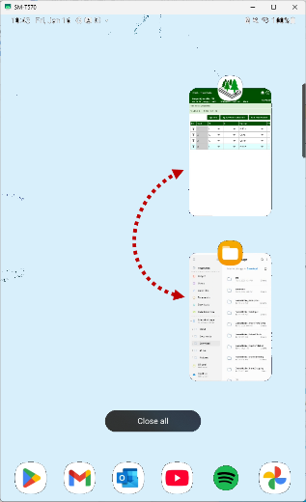
  - Pay special attention to the Tree Against Subpopulation check section.
- There are NO sample design selection criteria matches to this tree.
Possible causes:
      - Tree shouldn’t have been sampled
      - Error in subpopulation definitions (i.e., Sample Design)
- There are TOO MANY sample design selection criteria matches to this tree.
Cause:
      - Error in subpopulation definitions (i.e., Sample Design)
- While in the Tree form, remember that Options > Sample Design will display the subpopulations without leaving the form. Use the Back button on the tablet to return to the Tree form when done.
- Use the Back button to return to the Exams Mobile main menu (aka, the Home screen)
- To view the output file, open My Files then navigate to the file; notice that it has the date and time stamp of when it was created.
- You don’t need to be connected to a network -- you can run Preload Check in the field as often as you want, even at the end of every plot, to make sure that all the tree records are covered by the appropriate subpopulations. The only thing to keep in mind is that a new text file is created on your tablet each time you run it, so you may need to do some periodic housekeeping to remove the ones that you don’t need any more.

Topic S: Data Report

This tool produces a text file that is typically used to help inspect data quality. It can be printed and brought to the field for contract or force account inspections.
- Select a Template or a Data File > select your Data File
- Data Report
- Results are placed in Internal storage > Download > ExamsMobile_DataReport
- To view the output file, open My Files then navigate to the file; notice that it has the date and time stamp of when it was created.
- To print it:
            - Move the file to your PC at OS (C:) > ExamsMobile_DataReport
            - Use a text editor such as Notepad on your PC to add missing Tree sample design Method and Expansion Factor for each setting. This is due to a bug in the software, and it will be repaired eventually.
            - Print to an available printer.

Topic T: Overview of Data Transfer, Backup, and Sharing Tools

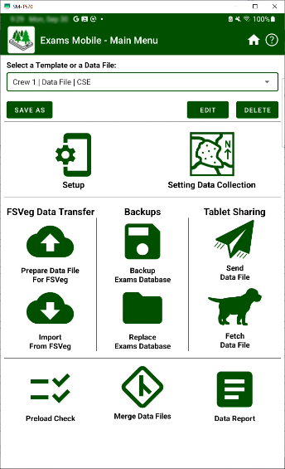

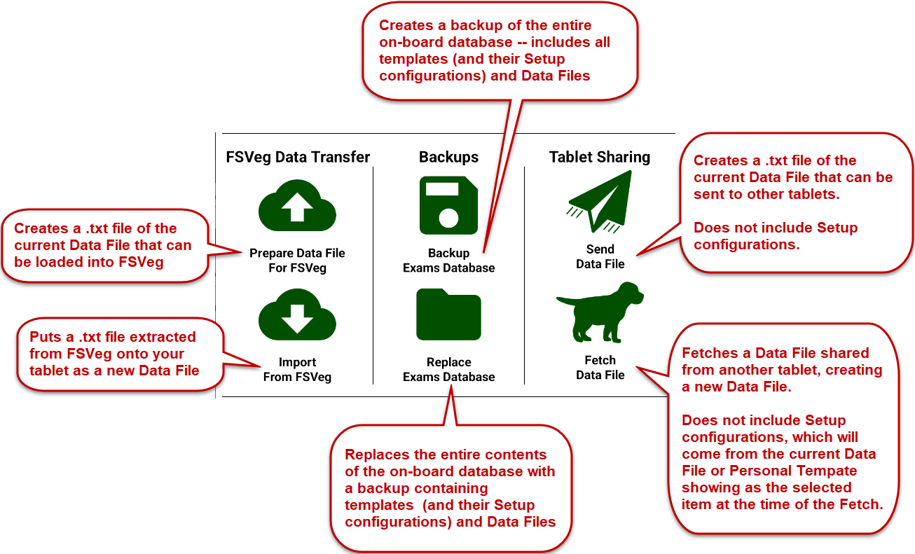

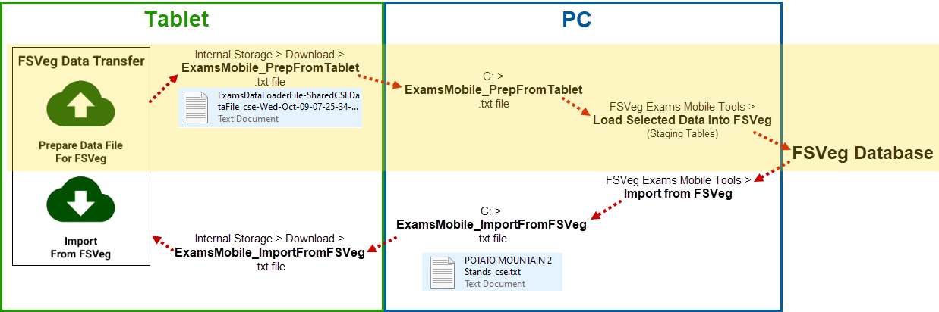
Topic U: Load Settings into FSVeg

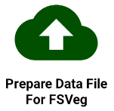
Prepare Data File for FSVeg
      - Main Menu > Prepare Data File for Database Loader -- Creates a .txt for the selected Data File shown in the window, which may contain several settings (stand exams).
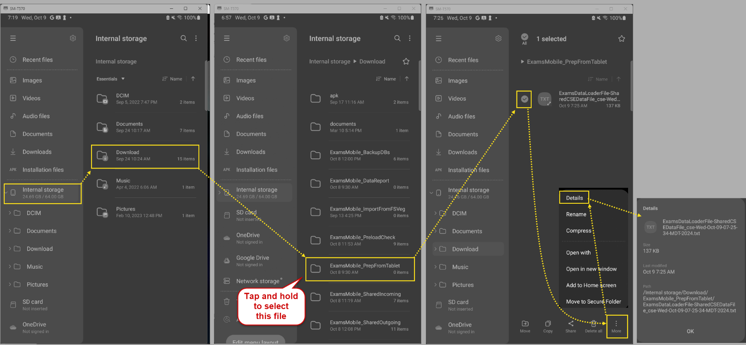
- The prepped Data File is automatically named and includes a date and time stamp, then saved to Internal Storage > Download > ExamsMobile_PrepFromTablet. To view the entire filename and its path on your Android tablet:

Move Prepped Data File from Tablet to PC (Do this frequently to avoid losing data to some unforeseen, catastrophic event, like an asteroid hitting your tablet)
- Connect tablet to PC with cable
- Windows File Explorer: Open separate windows for:
  - Tablet: Internal storage > Download > ExamsMobile_ExamsMobile_PrepFromTablet
  - PC: OS (C:) > ExamsMobile_PrepFromTablet
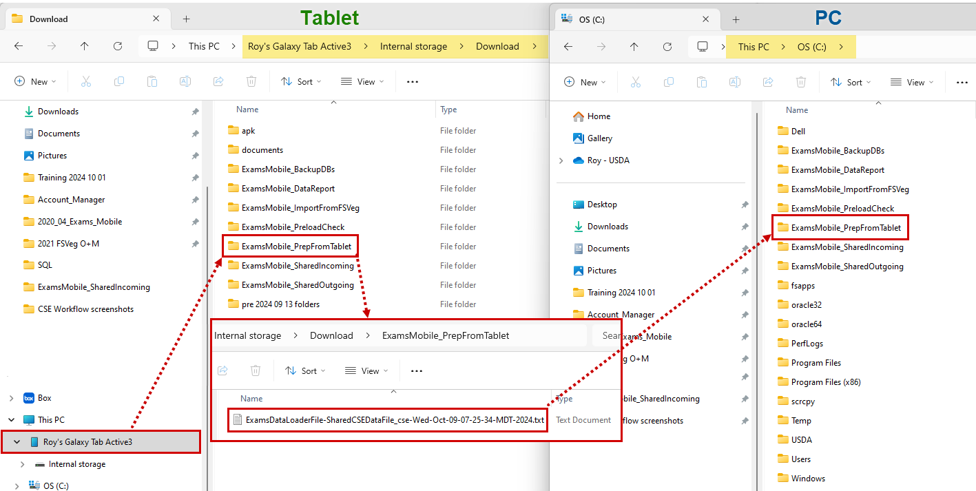
  - Arrange the two windows side-by-side, like this, to make it easier to transfer the files:
  - Copy the ExamsDataLoaderFileCSEDataFile_<etc.> from the tablet to the PC

NRM Dashboard > FSVeg Main Menu > Exams Mobile Tools > Exams Data Loader
      - https://iwebtrn.fs.usda.gov/login/welcome.html (Train A environment for this class)
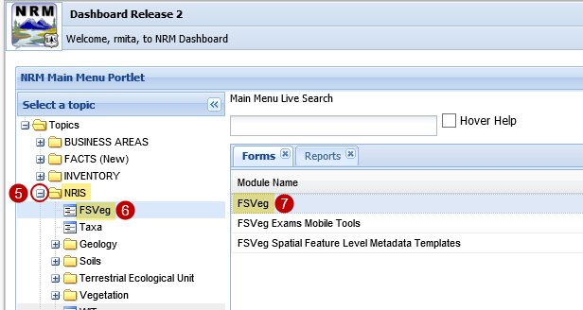
      - Default NRM Dashboard
      - USDA Employee/Contractor
      - PIV/CAC > Enter your PIN
      - Plus sign (+) next to NRIS
      - FSVeg (appears below NRIS)
      - FSVeg

The FSVeg main menu window will open; select Exams Mobile Tools > Exams Data Loader:
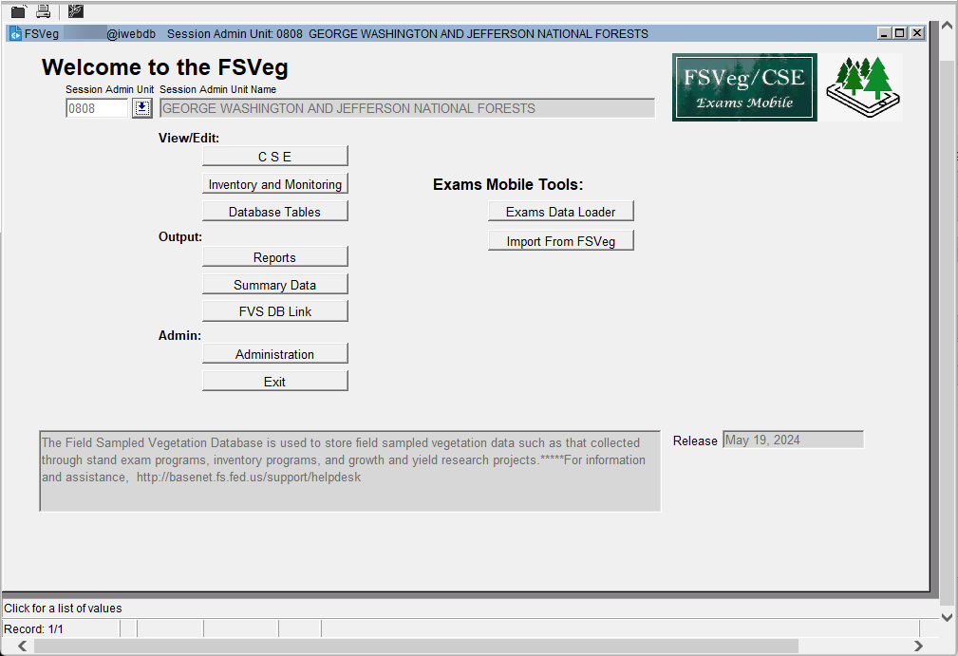

        - Select a File: Brings your Prepped Data into the form so that you can select which settings to load. The form will automatically begin looking in This PC > OS (C:) > ExamsMobile_PrepFromTablet. Open the folder where you’ve put your Prepped for Data Loader file and select it:
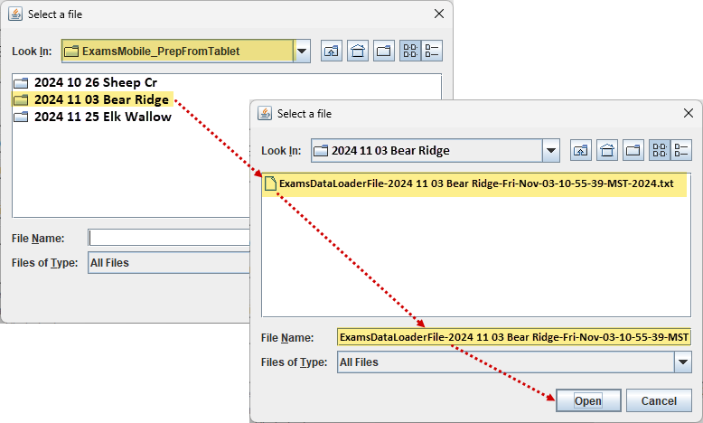
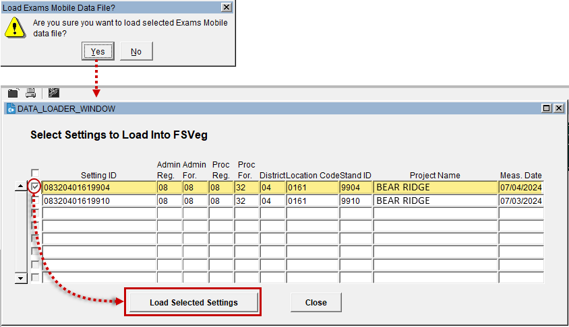
Troubleshooting:
    - When trying to bring in a prepped data file with Browse and you instead receive this error:
It means that your file is not a prepped data file and was instead created with the Send or other tool on the tablet. The solution to this is to return to your tablet and use the Prepare Data File for FSVeg tool to create the appropriate file.

- Load Selected Settings.
  - If any settings already exist in FSVeg (i.e., same setting id, measurement date, purpose code, and exam levels), then you will have the option to either overwrite the existing data or cancel loading.
  - Settings with data errors will not be loaded and you will be informed of them.
  - You will be notified when loading is complete.
  - If it seems as if nothing is happening with your load attempt, look in the lower left message area of the window for errors:
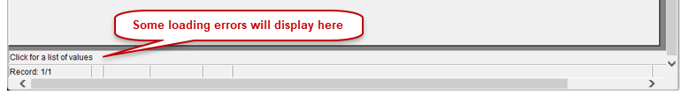
  - FSVeg Spatial implications: If the Location is checked out for an FSVeg Spatial editing session, you won’t be able to load data into it.

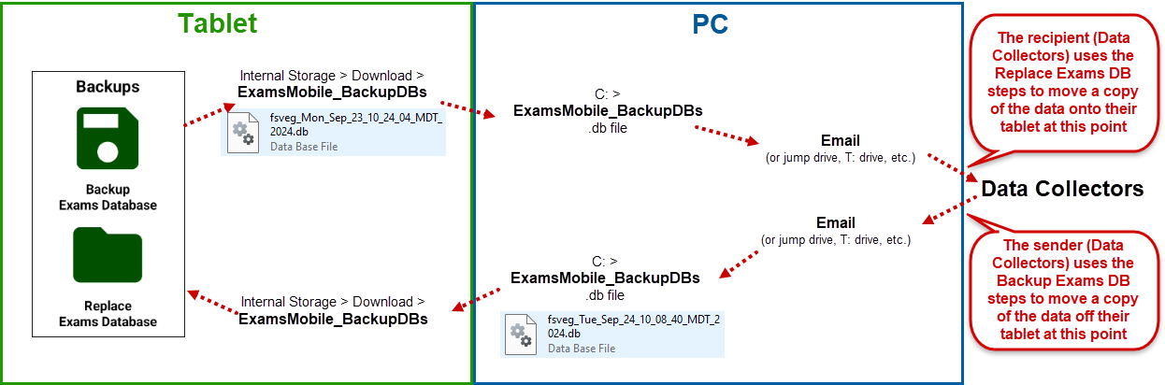
Topic V: Backups

Backup Databases are used to save a backup of all Exams Mobile Personal Templates and Data Files. Besides working great as backups, they are also an excellent way to pass Personal Templates and Data Files to others. The receiving tablet should perform a backup prior to replacement, since otherwise any existing Personal Templates and Data files would be lost.


Backup Exams Database:

To create a backup of the onboard SQLite database that holds all the templates and data files:
- Back up Exams Database – Creates a .db file from the currently active SQLite database in Exams Mobile containing the Regional Templates, Personal Templates, and Data Files.
- Rename it (e.g., crew_1_backup.db) or accept the default w/ timestamp
- It will be saved to: Internal storage > Downloads > ExamsMobile_BackupDBs
- Connect tablet to PC
- Windows File Explorer: Open separate windows for:
        - Tablet: Navigate to Internal storage > Download > ExamsMobile_BackupDBs
        - PC: OS (C:) > ExamsMobile_BackupDBs
        - Drag-and-drop crew_1_backup.db from tablet to PC
- The SQLite database crew_1_backup.db is now available for you to transfer via email, jump drive, T:\ drive, etc.


Replace Exams Database:

To use a SQLite database that someone has made available to you:
- On your PC, save it to OS (C:) > ExamsMobile_BackupDBs
- Connect tablet to PC
- Windows File Explorer; open separate windows for:
- Tablet: Navigate to Internal storage > Download > ExamsMobile_BackupDBs
- PC: OS (C:) > ExamsMobile_BackupDBs
- Drag-and-drop crew_1_backup.db from PC to tablet
- On your Android tablet, select Replace Exams Database;
  - Navigate to Internal storage > Download > ExamsMobile_BackupDBs
  - Select crew_1_backup.db
  - You can save the current SQLite database as a .db file in Downloads if you wish
  - Replace Current Database
- The SQLite database crew_1_backup.db has replaced the content in the onboard SQLite database and is available for use.
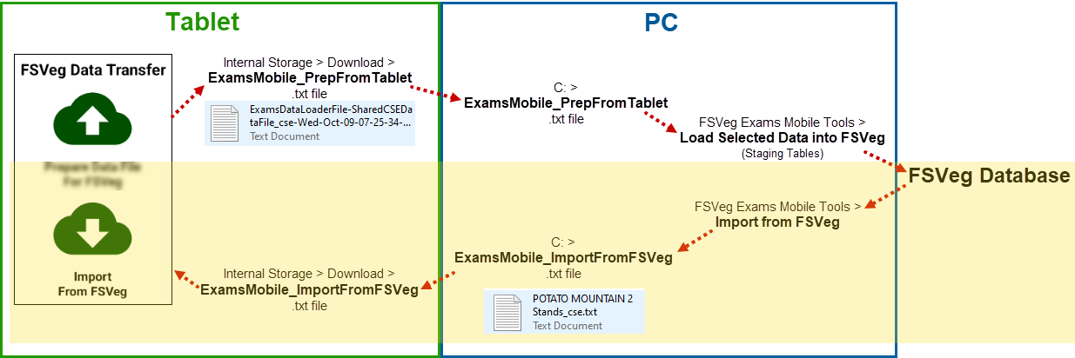
Topic W: Importing Data Files from FSVeg

If needed, you can pull Common Stand Exam data from FSVeg, move it to your Android tablet, and open it in Exams Mobile. This isn’t very common, but in the past people have wanted to have data from FSVeg loaded onto their tablet (and alternative to this is to simply put a text file created from Data Report onto their tablet. There are some considerations pertaining to the Setup configurations that will be assigned to them:
- Common Stand Exam data stored in FSVeg is no longer associated with the Setup (User Definitions, Field Selections, and Default Sample Design) information under which it was collected, so all this information will instead be supplied by the configuration of whatever Regional Template, Personal Template, or Data File that you have selected at the time you tap on the Import From FSVeg icon in Exams Mobile on the tablet:

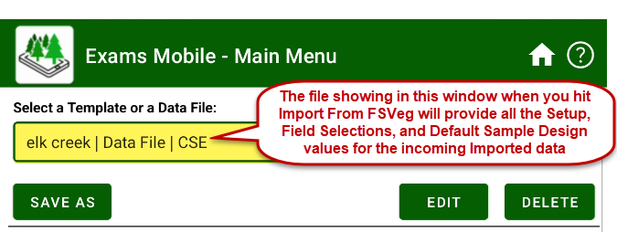
- As a result, it is advised to select a Template or Data File whose configuration is as close as possible to the one under which the data was collected, especially in terms of the admin and proclaimed units, since the forest-specific species lists would be appropriate for the incoming data:
  - Admin Region
  - Admin Forest
  - Proclaimed Region
  - Proclaimed Forest
But you might also consider having the other LOVs populated if the incoming data used them. Otherwise, their values may be flagged as incorrect, since they would not exist in User Definitions. Examples include:
- EV Ref and Codes
- PV Ref and Codes
- User Fields for Setting, Plot, Tree, Veg
- and so on.

The imported file will be saved in Exams Mobile as a Data File named NewCSEData.cse. It is advised that you edit this generic name to something that is meaningful and distinctive, however, especially since it can easily be overwritten if you import another file onto the tablet.
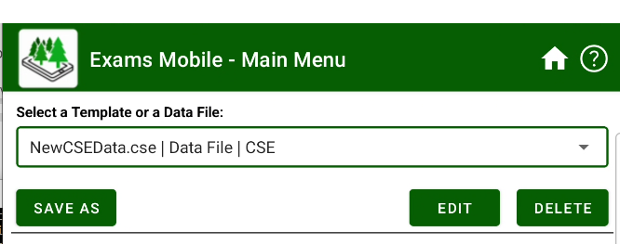

- The imported data can be treated as any other Data File in terms of viewing, editing, etc.

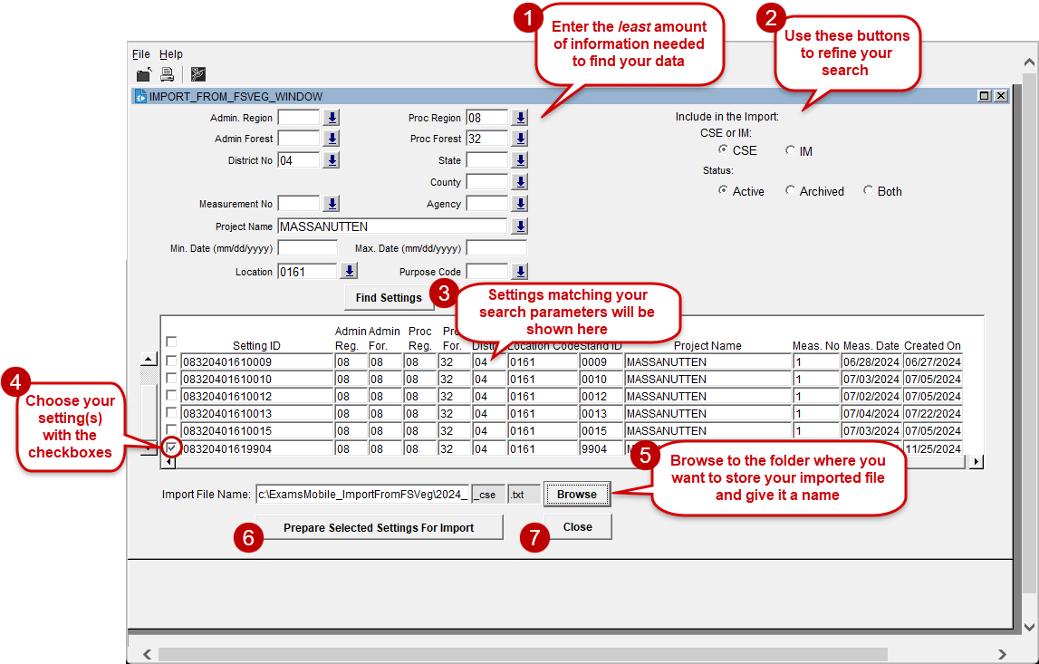

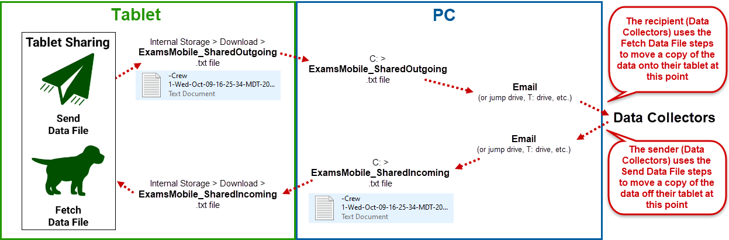
Topic X: Tablet Sharing

The Tablet Sharing tools are used to pass a single, selected Data File from one tablet to another (via a PC and email or jump drive, etc.) without disrupting the existing Personal Templates and other Data Files on the receiving tablet.
The prerequisite is that the receiving tablet has a copy of the same Personal Template that was used to create the incoming data file, or at least has a Data File whose Setup (User Definitions, Field Selections, and Default Sample Designs).
The reason this is important is that Shared Data Files do not retain their original Setup configurations (User Definitions, Field Selections, Sample Designs). Instead, these will be inherited from the Personal Template or Data File that is showing in the Select a Template or Data File box at the time Fetch is used on the receiving tablet
Send Data File

      - Select Data File
      - Send Data File
        - Saves -<Data File name><date and time stamp>.txt in Internal storage > Download > ExamsMobile_SharedOutgoing
- Connect tablet to PC
- Windows File Explorer: Open separate windows for:
        - Tablet: Navigate to Internal storage > Download > ExamsMobile_SharedOutgoing
        - PC: OS (C:) > ExamsMobile_ SharedOutgoing
        - Drag-and-drop -<Data File name><date and time stamp>.txt from tablet to PC
- -<Data File name><date and time stamp>.txt is now available for you to transfer via email, jump drive, T:\ drive, etc.
There is a bug in the Fetch tool that limits its ability to read more than 11 settings from a .txt file created by the Send tool. For this reason, if you need to transfer a Data File containing more than 11 settings, a workaround would be to make copies of that Data File, then pare down each to 11 settings or less, then run Send on each one. The alternative would be to use the Backup DB tool instead.

Fetch Data File

- Save the received Data File to OS (C:) > ExamsMobile_ SharedIncoming
- Connect tablet to PC
      - Windows File Explorer: Open separate windows for:
        - Tablet: Navigate to Internal storage > Download > ExamsMobile_SharedIncoming
        - PC: OS (C:) > ExamsMobile_ SharedIncoming
        - Drag-and-drop -<Data File name><date and time stamp>.txt from PC to tablet
      - On your tablet:
  - Select either a Personal Template or Data File with a Setup configuration appropriate for the incoming data. Why? Because the Fetched incoming data file will inherit the Setup configuration (User Definitions, Field Selections, and Default Sample Designs) of the selected Template or Data file.
  - Fetch Data File >
    - Select -<Data File name><date and time stamp>.txt
    - Import Data File
  - SharedCSEDataFile | Data File | CSE (or SharedIMDataFile | Data File | IM)
    - EDIT – Rename this Data File for clarity and to be unique; otherwise, the next Fetched or imported file will overwrite this one entirely and you’ll lose it.
- The new Data File is now available on your tablet along with any other existing Data Files you had prior to the Fetch.

For the next topic, we’ll use the Data Files in the following folder:
There is a bug in the Fetch tool that limits its ability to read more than 11 settings from a .txt file created by the Send tool. For this reason, if you need to transfer a Data File containing more than 11 settings, a workaround would be to make copies of that Data File, then pare down each to 11 settings or less, then run Send on each one. The alternative would be to use the Backup DB tool instead.

OS (C:) > ExamsMobile_SharedIncoming

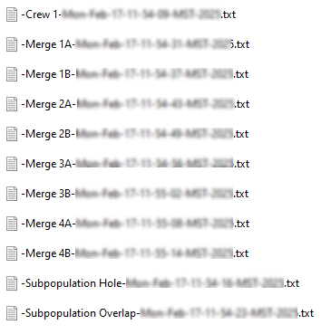
- On the Exams Mobile main menu (aka Home page), select Personal Templates > [your Personal Template]
- Connect tablet to PC
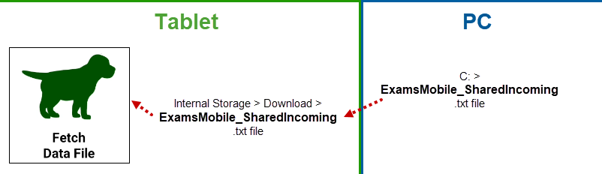
- Fetch Data File: Follow the directions in the prior Topic to move and rename these Data Files to the tablet’s Internal storage > Download > ExamsMobile_SharedIncoming folder:

Internal storage > Download > ExamsMobile_SharedIncoming | After Fetch, rename (EDIT) the Data File in Exams Mobile to:
-Merge 1A- etc.- | Merge 1A
-Merge 1B- etc.- | Merge 1B
-Merge 2A- etc. | Merge 2A
-Merge 2B- etc. | Merge 2B
-Merge 3A- etc. | Merge 3A
-Merge 3B- etc. | Merge 3B
-Merge 4A- etc. | Merge 4A
-Merge 4B- etc. | Merge 4B
-Subpop Hole- etc. | Subpop Hole
-Subpop Overlap- etc. | Subpop Overlap

Topic Y: Bad data examples
Subpopulation Hole and Subpopulation Overlap
Do the following for the Subpop Hole and the Subpop Overlap Data Files:
- Select the Data File
- Preload Check
  - Results text file appears. Pay special attention to Tree Against Subpopulation Check
  - Remember, the results are in a text file is saved to Internal storage > Download > ExamsMobile_PreloadCheck
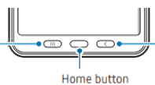
- Toggle between Exams Mobile and the Preload Check results text file:
  - Back button to return to the main menu.
  - Tablet’s Home button to show the desktop
  - My Files
    - Internal storage > Download > ExamsMobile_PreloadCheck
    - Select the file. If this is the first time you’ve opened a text file, a little dialog box will open, asking you what app you want to use to open it. Choose:
      - HTML viewer
      - Always
    - The file will be displayed.
  - Use the Running Apps button to toggle between Exams Mobile and the Preload Check results text file. In this way, you can quickly reference any errors and make corrections to either the subpopulation definitions (Setting’s Sample Design) or the tree/veg/downed woody/surface cover records as needed. The way I usually do it is to:
    - Find the tree record that is flagged with the error:
      - Does it fit into one or more subpopulations?
      - Does it fit into none of them?
    - Examine the Tree subpopulation records:
      - Are they mutually exclusive?
      - Are there any gaps between subpopulations?
- Typically, what you would do right after repairing a Data File like this is that you would load it into FSVeg. Please feel welcome to do so with your repaired Data File, using the Train A environment (don’t load this data into the Production environment).

Sampling Trees diagram in Appendix 6

Topic Z: Merge
The Merge tool is used to:
- Consolidate different plots from one stand that were collected on two different tablets. The end result is one setting with all the plots in it on the primary tablet.
- Consolidate multiple settings from two different tablets into one data file on the primary tablet. This is done mostly to make handling and storage of data files easier in the long run.
We will cover the most common 4 scenarios that people encounter.
Scenario 1: As the Crew Lead, you sent two crews to a single stand one day to collect different plots in the stand, with the intent to merge all the plots into one stand exam. Crew A collected plots 1, 2, 3, and 4. Crew B collected plots 5, 6, and 7. When they were done, they used Send to format their respective files and emailed them to you. You now have them in Internal storage > Download > SharedIncoming on your tablet.
- Preload Check both to make sure all is well.
- Merge Data Files

  - Select the Merge 1A Data File – the first file you select will be the Primary Data File and will end up with all the plots, while the other will be the Secondary Data File and remain unchanged.
  - Merge
  - Designate Merge 1B as the Secondary Data File
  - Make sure that the desired setting is checked (√)
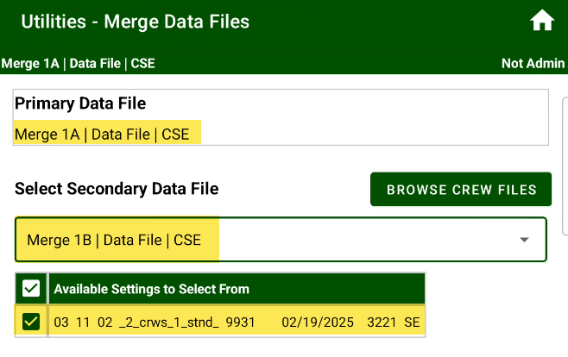
  - Merge into Primary Data File
  - If both Data Files have settings with duplicate identifiers (Admin Region, Admin Forest, Proclaimed Region, Proclaimed Forest, District, Location, Setting ID, Measurement Date, Exam Levels, Exam Purpose), then you’ll have a choice:
    - Merge: Plots from the setting in the Secondary Data File will be copied to its corresponding setting in the Primary Data File.
    - Overwrite: Plots from the setting in the Secondary Data File will replace (i.e., obliterate) all plots in its corresponding setting in the Primary Data File.
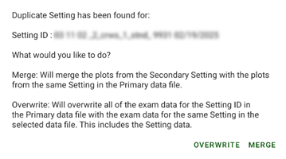
  - Back button to return to the previous screen. Notice that the Merge into Primary Data File button has been grayed out.
  - View the plot results for that Primary Setting in Data Collection. You can also Preload Check the file.
Scenario 2: One crew collected different plots in the same stand over two days on different tablets. Again, the job is to merge all the plots into one stand exam. Remember that the measurement date needs to be the same on both settings, and most people choose the latter date. Merge the two settings that are in the two data files:
The Data Files you will use for this exercise are:
- Merge 2a, with plots 1, 2, 3, and 4
- Merge 2B, with plots 5, 6, and 7
Remember, if the settings have different measurement dates, they will be treated as separate stand exams and the plots will not be merged into one stand exam. Instead, you’ll end up with two separate stand exams in the Primary Data File; one with plots from the first day, and the other with plots from the second day.
This will happen to you if you didn’t catch the fact that the measurement dates were different.
To recover from this:
- Delete the second setting from the Primary Data File
- Set the measurement date of the setting in the Primary Data File to match that of its counterpart in the Secondary Data File. It’s customary to use the latter of the dates as the measurement date.
- Try merging them again; if the dates are identical, the result will be one setting in the Primary Data File with all the plots in it.
- Preload Check that setting.

Scenario 3: The intent was to merge the plots collected by two different crews from a given stand into one stand exam, but one of the crews made a mistake; their large tree subpopulation has a different BAF.
The Data Files you will use for this exercise are:
- Merge 3a, with plots 1, 2, 3, and 4
- Merge 3B, with plots 5, 6, and 7
Did they really use the wrong BAF? Or did they actually collect trees using the correct BAF but just wrote it down wrong? The solution you implement depends on what they actually did.

Scenario 4: The intent was to merge the plots collected by two different crews from a given stand into one stand exam, but Crew B made some sort of mistake and ended up with a duplicate plot number.
The Data Files you will use for this exercise are:
- Merge 4a, with plots 1, 2, 3, and 4
- Merge 4B, with plots 4, 5, and 6
Did they just mis-number their plots? Or are the plot numbers correct, but they measured a plot that Crew A already measured? As before, the solution you implement depends on what they did.

Topic AA: Oracle Forms
- Log into NRM:
  - Class (Train A): https://iwebtrn.fs.usda.gov/login/welcome.html - use your student account
    - Default NRM Dashboard
    - Log In with your student account and password
  - Real life (Prod): https://iweb.fs.usda.gov/login/welcome.html - use your real account
    - Default NRM Dashboard
    - Log In with PIV/CAC
  - Real life (Citrix): https://citrix.fs.usda.gov/Citrix/StoreWeb/ - use your real account
    - Navigate to:
      - Categories
      - National Applications
      - Natural Resource Manager
      - NRM Dashboard
      - Default NRM Dashboard
      - Log in with PIV/CAC or your real username and password
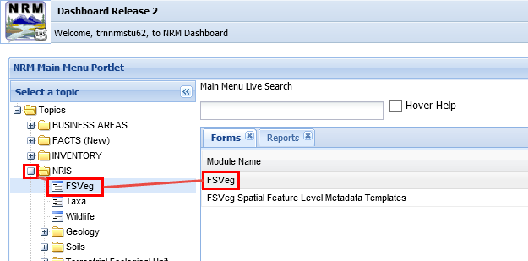
- NRM Dashboard Release 2:
  - Expand the ‘+’ sign next to NRIS
  - FSVeg (appears below NRIS)
  - FSVeg (appears on the right)

You’ll arrive at the FSVeg Main Menu:

NOTE: If the screen that appears after the steps in C. above:
a. stays blank (white), your PC is probably missing Oracle Client.
b. stays blank (grey), wait—it will eventually become…
c. the Java blue circle animation appears over the window, wait—it will eventually become…
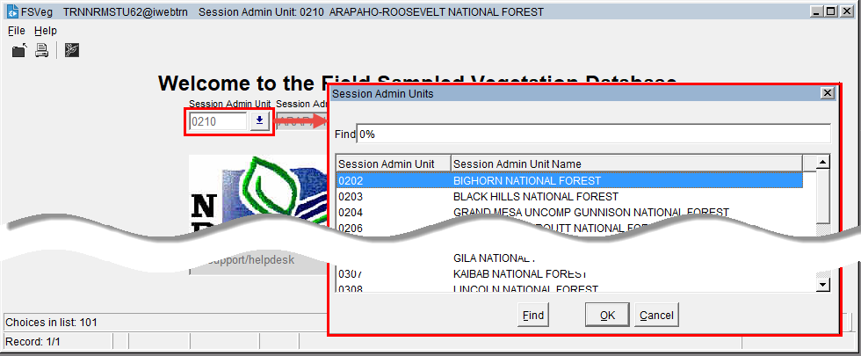
Set your Admin Unit to the Region and Forest for the training (in real life, select your actual unit):

View / Insert / Edit / Delete
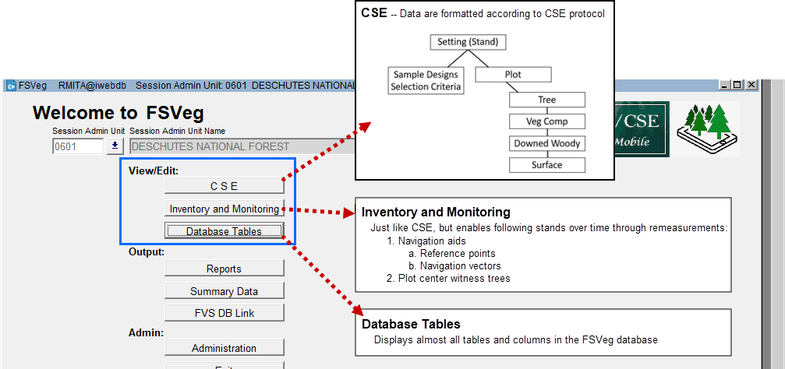

CSE (and Inventory and Monitoring, which is very similar with some added features)
- Data are formatted according to the CSE Protocol (see diagram above); it’s very similar to ExamsPC/PDR
- Find the setting of interest using Preferences
Preferences aka Search Filter
- Appears in almost all the functional areas in one form or another.
- Used to quickly find your data of interest.
- Specify the least amount of information needed (or you may not find the data you are looking for).
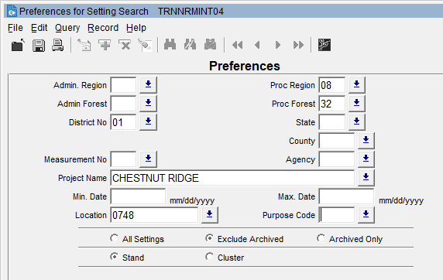

Try it - Get into the CSE form, use the Preferences to find a setting, and explore the forms such as Sample Designs, Plot, Tree, Veg Comp, and Downed Woody.

Database Tables
FSVeg was designed to hold any plot-based forest vegetation data; there are many more data elements and tables than what are used in Common Stand Exam. So this area enables you to look at almost every table in the database. Notice that it still uses this general plot-based survey concept; there’s just a lot more at each level.
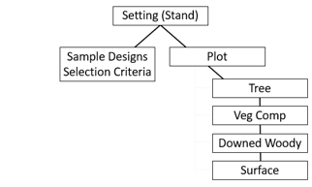
Try it - Get into the Database Tables form, use the Preferences to find a setting, and explore the forms using the navigation buttons on the left. Can you find where you would archive a setting?

Topic BB: Outputs
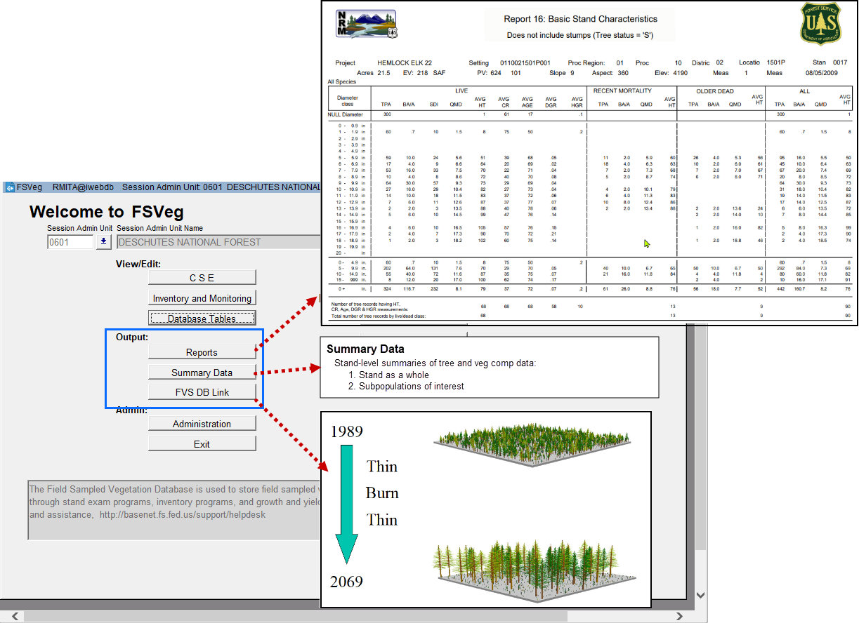

Reports
Two different ways to choose settings for a report:
- Preferences, aka Report Filter
- Setting List - Build your own or use one already available.
There are 32 reports:
- The first 15 are simple, general reports that involve pulling the data right out of FSVeg without doing much computations. They were designed to answer questions such as “show me all the settings in my project area.”
- The others were designed to answer much more complex questions:
Report | Name | Description
16 | Stand Table | Summarizes TPA and BA/ac by DBH and Live, Recent Mortality, Older Dead, and All. Very flexible and customizable so that you can tailor it to your analysis needs, such as Forest Plan Standards and Guides parameters relevant to tree diameters. It and Report 17, Volume Table, formed the basis for the original FSVeg Summary function.
17 | Volume | Summarizes gross volumes/ac (cubic, merch cubic, board foot) by those same classes and equally versatile.
18 | Species Configuration | Lists the equations and parameters used to compute volume, height, site index, etc. for each species by Region or Forest.
19 | CSE Comprehensive | Data are formatted according to the CSE protocol by setting.
20 | CSE Brown’s | Just the Brown’s Downed Woody part of Report 16.
21 | Multi-Stand | Just like Report 16 - but it treats all the settings you include as if they are one big setting. You get to choose how you would like the plots weighted. A quick way to mashup data from multiple stands without actually merging them.
22 | Multi-Stand Volume | Like Report 21, but for volume.
23 | Acres by Age Class | Summarizes acres by age class across the specified settings. But the Stand Year of Origin, which isn’t collected in CSE, must be populated.
24 | Vegetation Structural Stage | Calculates VSS for by setting using R2, R3, and R4 algorithms.
25 | Cover Summary | Summarizes vegetation composition and surface cover data by setting.
26 | Live/Dead Tree Stocking | Summarizes TPA, BA/ac, and QMD by species and standard diameter classes used in R8 and R9.
27 | NEAT-R TPA | Summarizes TPA and species classes suitable for R10 NEAT-R analyses.
28 | NEAT-R Volume | Summarizes volume/ac by diameter and species classes suitable for NEAT-R analyses.
30 | User Code | Retrieves setting, plot, tree, and veg comp data codes.
31 | Stand Exam Data Source | Identifies the most recent FSVeg Spatial edit that created a stand exam record in FSVeg.
32 | Stand Exam Data Source Detail | Displays the entire set of FSVeg Spatial edits that resulted in the stand exam record in FSVeg.
33 | FSVeg Spatial Linkage Status | Displays whether a setting is, was, or can’t be linked with a polygon in FSVeg Spatial.

Try it . . .

1. Click on the ‘Reports’ button and, using the report preferences option (radio button), run one of the simpler reports (1 through 15).
A. In the Preferences screen, always specify the minimum amount of information needed to select the stands you want. Here’s an illustrative example from Region 2:
i. Set the Preferences as follows:
a. Admin Region = ‘02’
b. Admin Forest = ‘03’
c. District No = ‘03’
d. Location = ‘040803’
e. State = ‘SD’
f. County = ‘103’
B. How do you know how many settings you’ve selected? Hint: The “All Setting Ids” option selects all settings that meet the user-defined criteria but does not display them.
i. To view a list of settings, select the ‘Single/Multiple Setting Ids’ radio button.
ii. To select individual settings, move the Ids from the left-hand box to the right-hand box.
C. How many settings do you get if you null out the County value? Or the State value?
D. What does ‘Excluding Archived’ settings do?

What if NO settings IDs appear in the left-hand box? What if no IDs are moved?
2. Report 16 – Stand Table
A. Select 3 settings using Preferences
B. Run Report 16
i. Fixed-Width Diameter Classes:
a. Select 1-inch diameter classes
b. Class min and max – These are initially populated so that you can see your actual data range for the settings you’ve selected, but you’ll almost never use them as the min and max. Why? Because the minimum is used as the class starting point, and if it’s something like 1.3 inches, then your classes will be 1.3-2.2, 2.3-3.2, 3.3-4.2, etc. Suppose you selected 1-inch diameter classes and your largest tree is 75 inches; do you really want to display 75 distinct diameter class rows? So set the values to what is useful for your analysis.
ii. Custom Diameter Classes:
a. This is here to enable you to customize your output to match your Forest Plan Standards and Guides, product specs, etc. for analysis
b. Add as many or as few as you wish.
c. They don’t need to be mutually exclusive or anything!
iii. Single Group Class :
• Will group output for anything larger than or equal to your specified minimum.
iv. Report Options:
• Select Species/Species Group for Report: Enter one or more species; note that a hardwood/softwood option can be selected and you can build your own custom species groups (this is to aid in analyses that are bounded by Standards and Guides, product specs, etc.).

Report 19 – CSE Comprehensive
Run this report on one setting
Summary Data
- Summarizes tree and veg comp data by setting:
  - Setting as a whole
  - Subpopulations of interest (like size classes, species, live/dead, you name it).
- NRV_SUMMARY role
- Summaries can be used to attribute veg polygons in FSVeg Spatial.
FVS_DB_LINK
- Extracts data for use in the Forest Vegetation Simulator (FVS).
- It’s easy! Just “answer me these questions three, ere the other side ye see”*:
  - Target Directory - It defaults to C:\FVSdata but create your own folder below that.
  - Default FVS Variant - For FS data, it doesn’t matter; pick anything.
  - Create/Select List
*Apologies to Monty Python.
Try it! - For extra credit, open your target directory and watch your files getting created. When the Access lock file disappears, the process is done.

Administration
Enables NRV_Wizards to manage Forest and Regional:
- Configurations - Applied across your entire Forest/Region (as applicable):
  - Species configuration - Warning: Don’t change anything without Regional Mensuration Staff collaboration and approval, since any changes are instantly applied to the entire Forest or Region. If you need to know the parameters used on your Forest/Region, run Report 18, Species Configuration.
  - Species group setup - Create species groups that are available to others.
  - Brown’s piece count display - Create Brown’s piece count diameter classes that others can use.
- Metadata:
  - Aerial photos - Enter them here for them to be available for data entry (reduces typos).
  - Fire info - Ditto.
  - Images - Ditto.
  - Data codes - Regionally defined; work with your Regional staffs if you need additional codes.
  - Setting lists - Create setting lists that are available to everyone. Especially useful for running multiple reports on the same set of settings, as well as for FVS_DB_LINK.
- Templates - Create templates available to everyone:
  - Diameter class template
  - Sample design template
- Other:
  - Synch spatial acres - Synchronize acres entered from CSE or Database Tables forms with digitized acres from FSVeg Spatial.
  - Reset Taxa lists - Choose a different Taxa list for those units that have access to more than one.
Topic CC: Contract Administration
Know your stuff
- CSE protocols
- Contract specs
- Your stand exam objectives
Develop a common understanding of the contract with the contractor
- Crucial to getting the desired results
- Start as early as possible
- Meet in the field to go through data collection – and offer to walk them through the inspection. So they see how the stand exam will be graded.
- Make sure the contractors know the specs – you will be holding them to it with the inspections
Correct problems while they are small
- Find and correct problems while there aren’t very many of them
- Inspect early and often at the beginning
- Make the first payment unit small (50 to 100 plots)
- Be aware if the contractor adds new crew people over the course of the season. Have the contractor let the COR know when that happens so that you can inspect that work quickly to ensure that quality is maintained.
Inspections
- About 10% of plots are inspected
- Inspection form: A lot of people have put a lot of thought into the system of point deductions. For this reason, be very reluctant to change point values, especially without considering what the overall effect of doing so would be.
- All inspectors must apply the contact specs uniformly. Having some inspectors being lenient and some inspectors being strict with the same specs on a given forest is very counterproductive. Everyone ultimately suffers, and you will guarantee that you won’t get the desired results. Remember, you won’t do anyone any favors by being lenient.
  - Remember, if the forest really doesn’t need a tight spec on a measurement, then the contract should be written up that way. For instance, if it’s ok for DBH to be recorded up to 0.5” from actual, then the contract should not specify a tolerance of 0.1”
- Objective (measured) items: Apply the contract specs as written.
- Subjective (estimated) items: This is the one area where you have some latitude. If a contractor’s estimate doesn’t match yours, but can be considered reasonable, you may accept it. Example: estimates of percent cover on the Veg Comp and Ground Surface Cover forms.
In general
- Most contractors are trying to do a good job; they know that doing so will get them paid in the least time and with the least hassle.
- Some people choose to implement quick plots rather than intensive ones, figuring they’ll just live with the poorer precision and data utility. But remember, half the cost of a stand exam is just getting the crew to each plot; once they are there, it doesn’t cost that much more to get better data.

Appendix 1: Request a User Management Application (UMA) Role
If you will be downloading data into FSVeg from ExamsPC or editing it in FSVeg, you will need an UMA role (Data Collector or Wizard). Obtaining a role is a two-step process: (1) submit a request and (2) notify your UMA manager.
1. Log into NRM: http://fsweb.nris.fs.fed.us/products/FSVeg/index.shtml then Login to NRM Dashboard
2. Once on the I-Web Dashboard:
A. Topics
B. System Maintenance
C. User Management Application (on the left side)
D. User Management Application (on the right side)
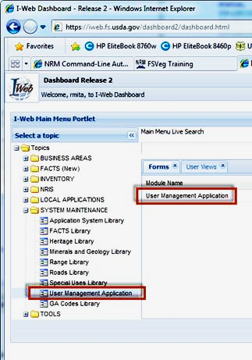
3. In the User Management Application:
A. Personal Info: remove the period (‘.’) from username if it’s there:
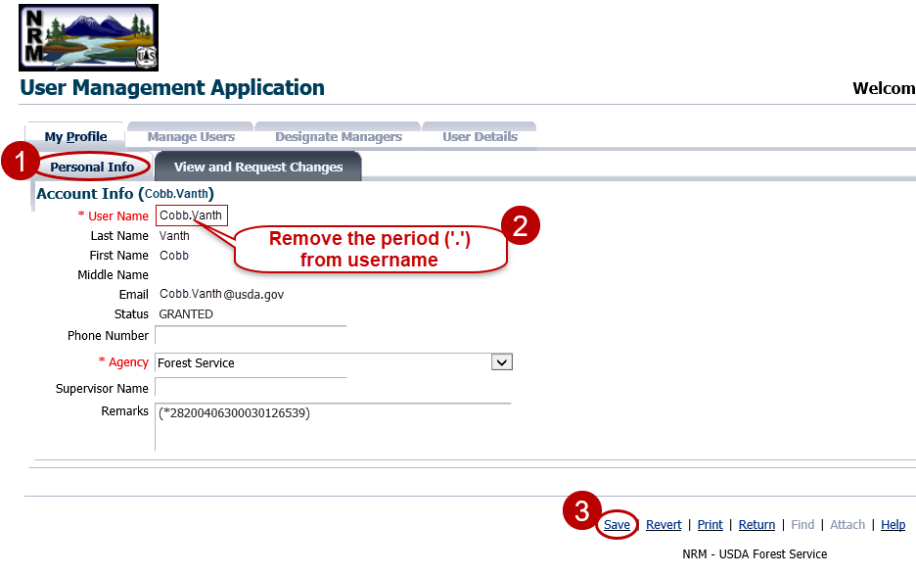

B. Request Account Changes (note that this is different from what you did for class in Train A):
i. Application Name: NRIS FSVeg
ii. Role Name: Data Collector
iii. Available Orgs / Filter: Select your admin region/forest
iv. Highlight the selection
v. Move (notice that it disappears from Available Orgs and appears under Requested Orgs)
vi. Add Selected Orgs
vii. Check that the selected role and organization appear in My Roles and Orgs
viii. Save
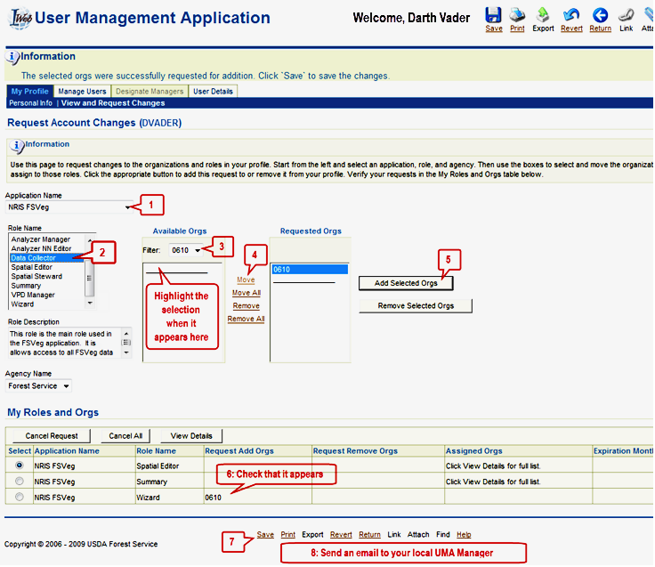
The UMA application may send you an automatic message to the effect that your request is being reviewed, but under no circumstances should this lull you into a false sense of well-being!
The reality is that NOTHING will happen until you follow the directions on the next page . . .
4. Crucial Step: Send an email to your local UMA Manager to the effect that you are requesting an UMA role and could they please approve it.
To find your UMA Manager:
A. NRIS Applications page: http://fsweb.nrm.fs.fed.us/applications/
B. User Management Applicaton (UMA)
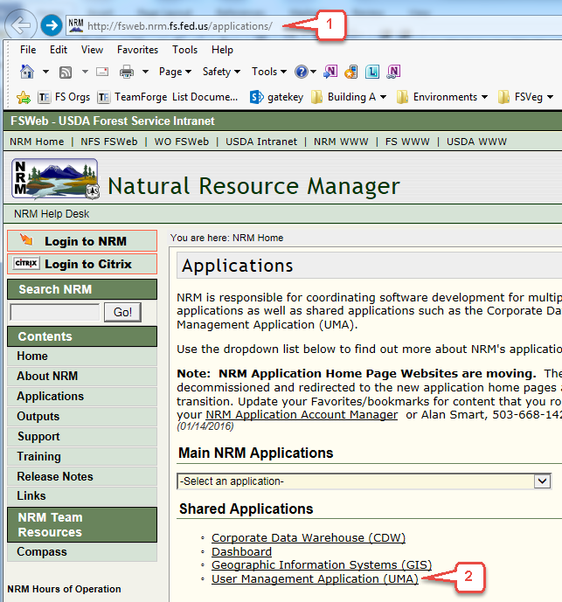
C. NRIS User Management Application (UMA) Managers by Unit (.xls)
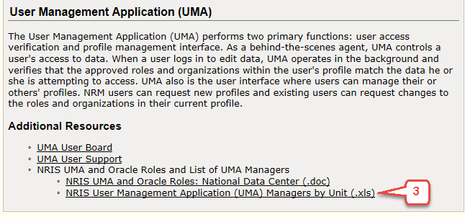

Appendix 2: Set your Admin Unit in FSVeg
- Log into NRM (Production, not TrainA):
http://fsweb.nris.fs.fed.us/products/FSVeg/index.shtml then Login to NRM
2. Once on the I-Web Dashboard:
A. plus-sign(+) next to NRIS
B. FSVeg (on the left side)
C. FSVeg (on the right side)
3. Set the Session Admin Unit on the FSVeg main menu:
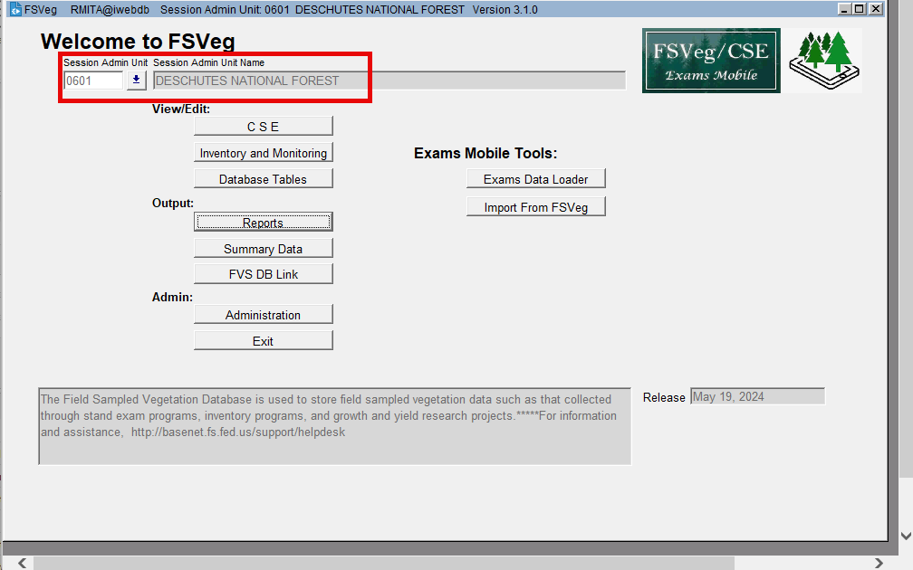
4. Those in regions 1 and 10 may be asked to select the appropriate TAXA list for various lifeforms; here’s an example from the Tongass NF:
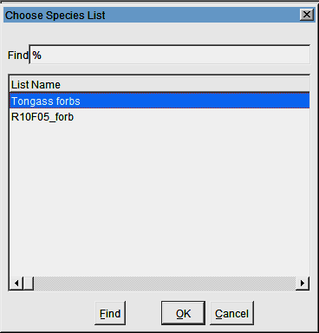

Appendix 3: Old Oracle Form - FSVeg Exams Mobile Tools
This was originally created in the spring of 2024 as a quick, temporary solution for the Preload Check, Merge, Data Report, Load, and import tools until a better, more permanent solution could be developed (which now exists as of February 2025). Although the original intent was to sunset these forms when the new tools become available, they are still useful for diagnosing issues, so they have been retained.

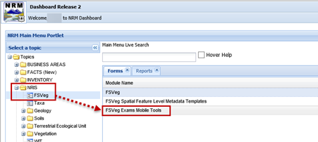
- Default NRM Dashboard
- USDA Employee/Contractor
- PIV/CAC > Enter your PIN
- Plus sign (+) next to NRIS
- FSVeg (appears below NRIS)
- FSVeg Exams Mobile Tools

The FSVeg Exams Mobile Data Transfer Tools window will open:

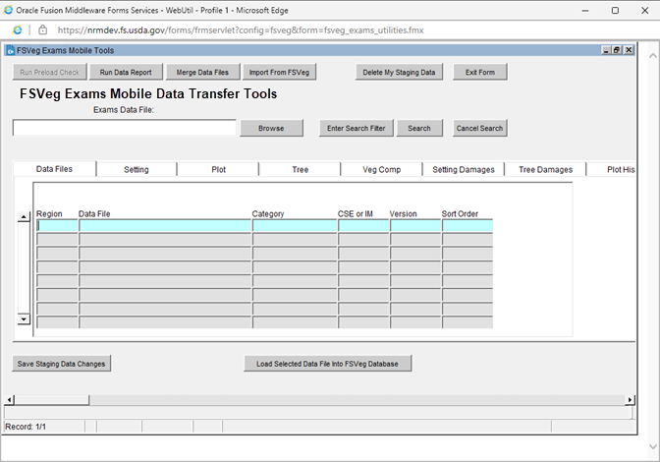

        - Browse: Brings your data into the Staging Tables so that you can view and edit it.
          - Desktop > This PC > OS (C:) > ExamsMobile_PrepFromTablet
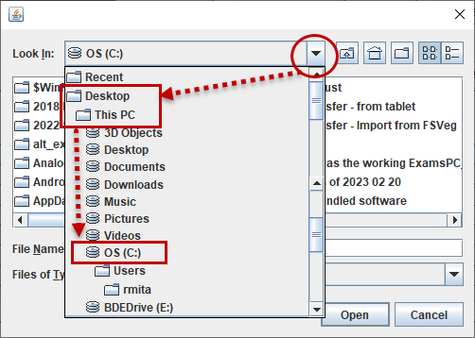

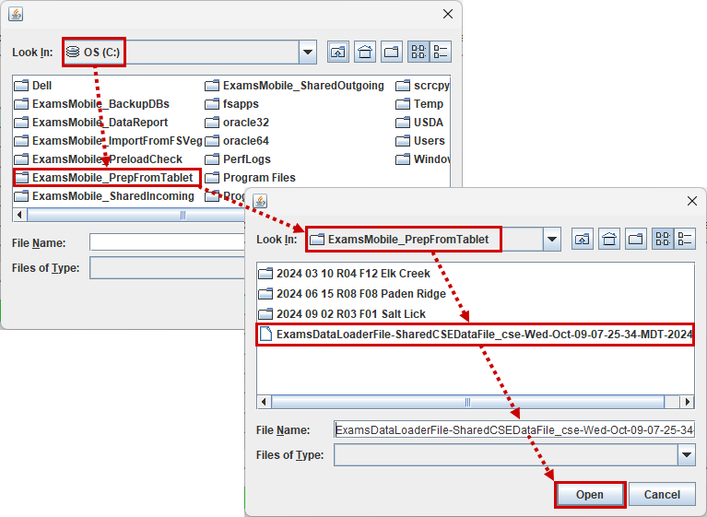

Select your Prepped Data File
and bring it into the Staging Tables

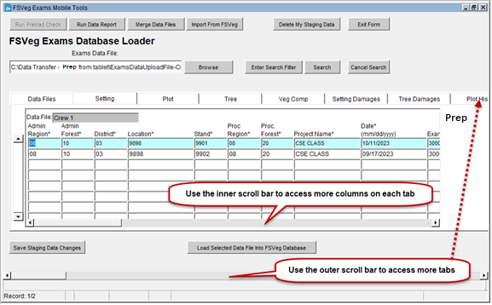

The Data File name
from the tablet
is retained

Data are brought into the Staging Table forms. Use the tabs and scroll bars to review its contents:
Data Files | Tree Damages | Tree Audit Check
Setting | Plot History | Field Selections
Plot | Sample Design | Fire Info
Tree | Downed Woody Material | Fire Info Details
Veg Comp | Growth Sample Tree
Setting Damages | Species of Mgt Interest

Browse enables you to:
    - View
    - Edit
      - Make changes directly in the form
      - Save them with Save Staging Data Changes
Troubleshooting:
When trying to bring in a prepped data file with Browse and you instead receive this error, it means that your file is not a prepped data file and was instead created with the Send tool on the tablet. The solution to this is to return to your tablet ad use the Prepare Data File for FSVeg tool to create the appropriate file.
When trying to g in a prepped data file with Browse and you instead receive this error, it means th file is no a prepped data file and was instead created tool on the tablet. The solution to this is to return to your tablet ad use the Prepare Data File for FSVeg tool to create th
Use Load Selected Data File Into FSVeg Database to load data into FSVeg on Train A

Appendix 4: Re-sizing the FSVeg Oracle window
The FSVeg Oracle window always opens a little truncated, so re-size each time to avoid hiding buttons and dialog boxes from yourself.

- The inner window (“Welcome to FSVeg”) is always a truncated at first. Grab the lower right corner of the outer window, then pull it down and to the right to make the outer window larger:
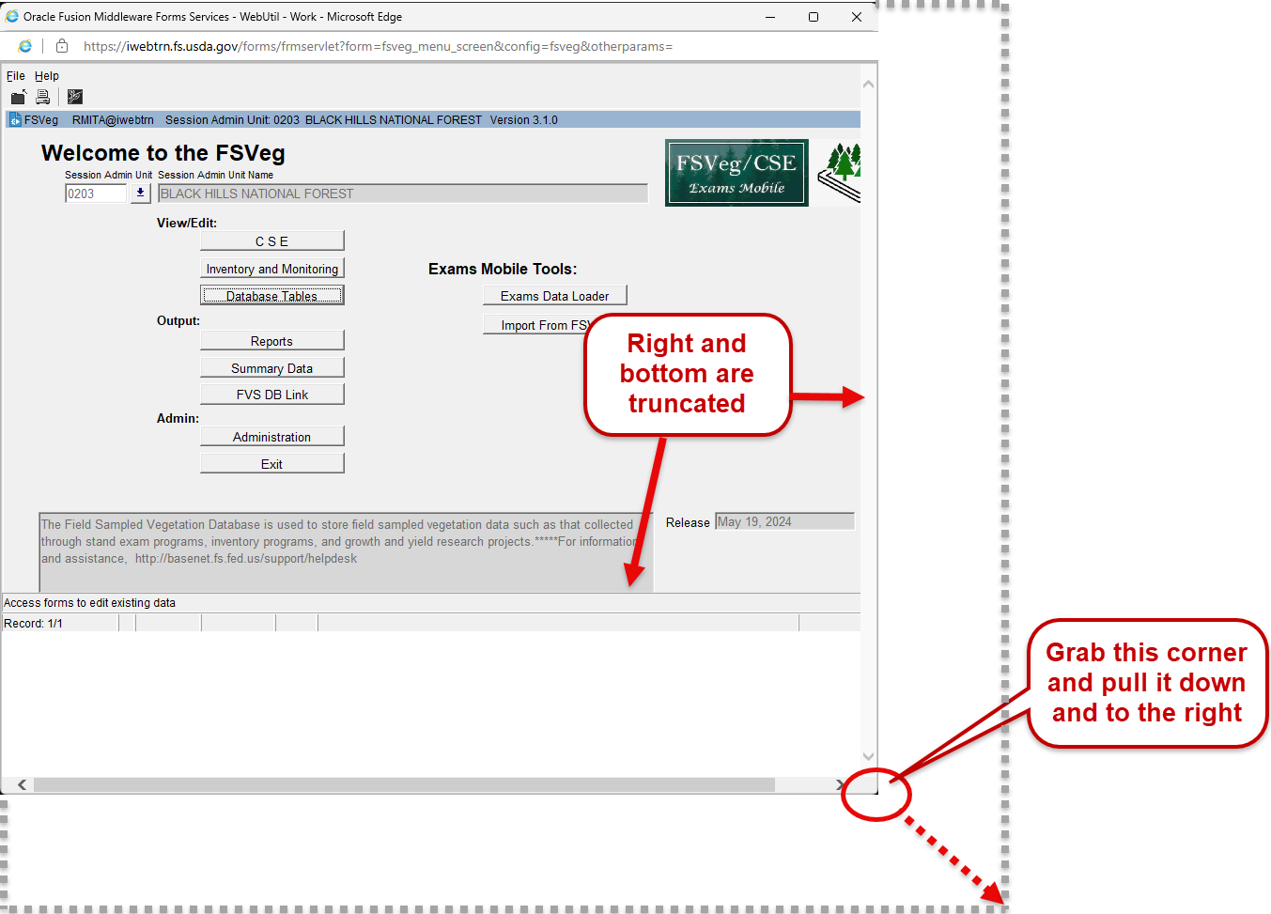
- Ctrl + scroll the mouse wheel to see more of the inner window, then re-size the outer window:
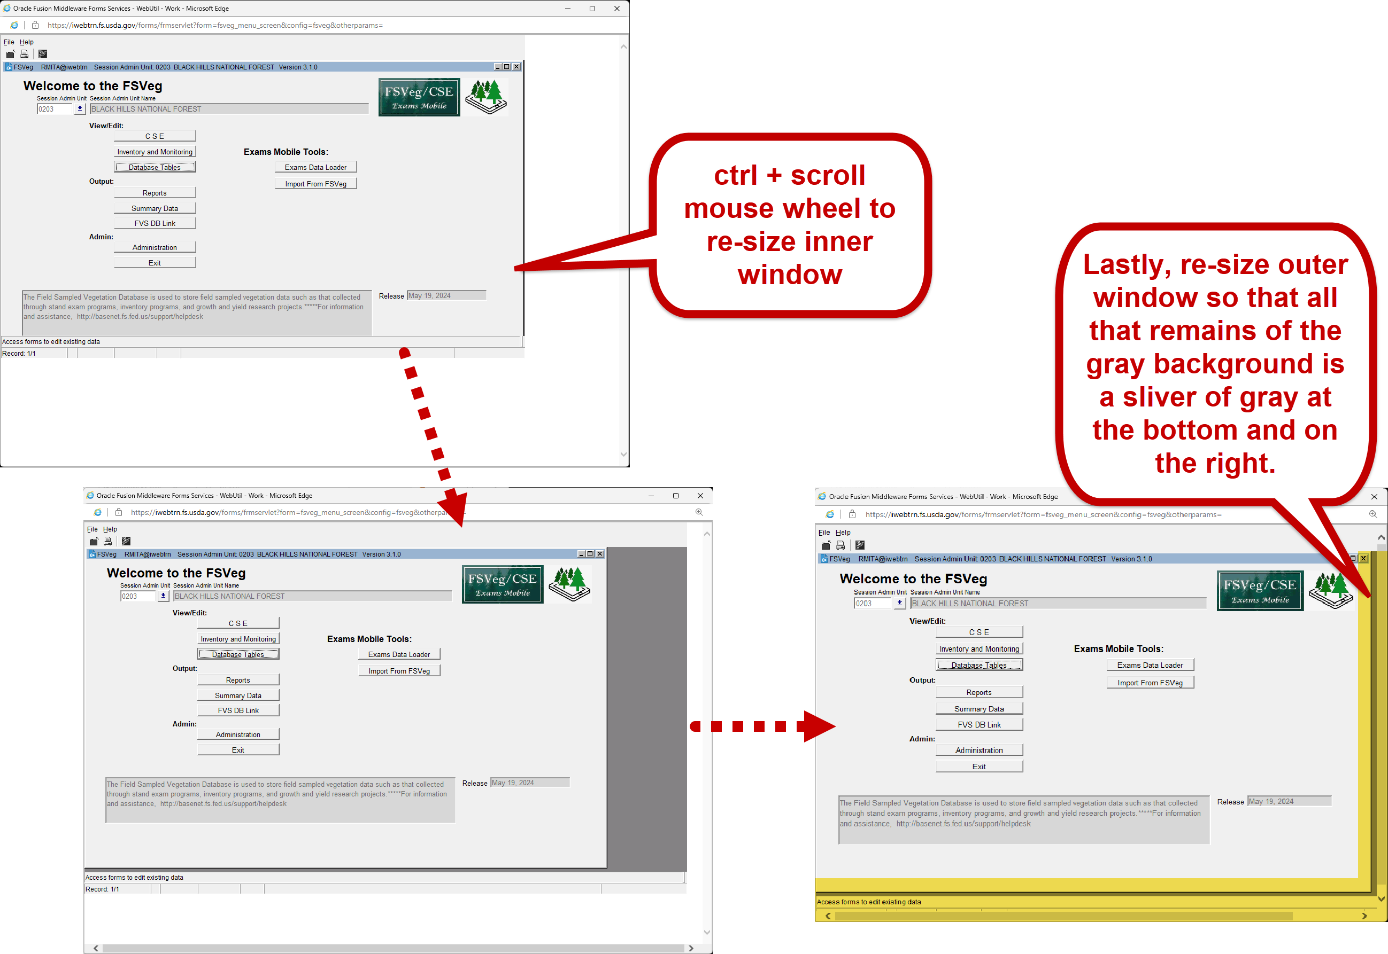
This is particularly important for:
  - Reports, where you can easily hide the report options from yourself:
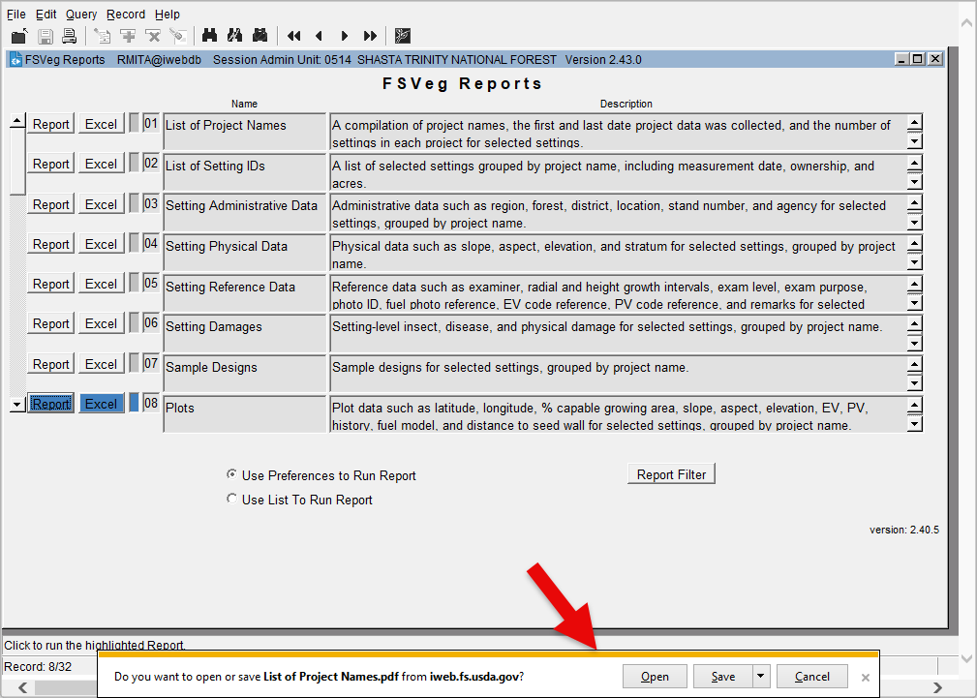

- Forms whose buttons are close to the edges, e.g.:
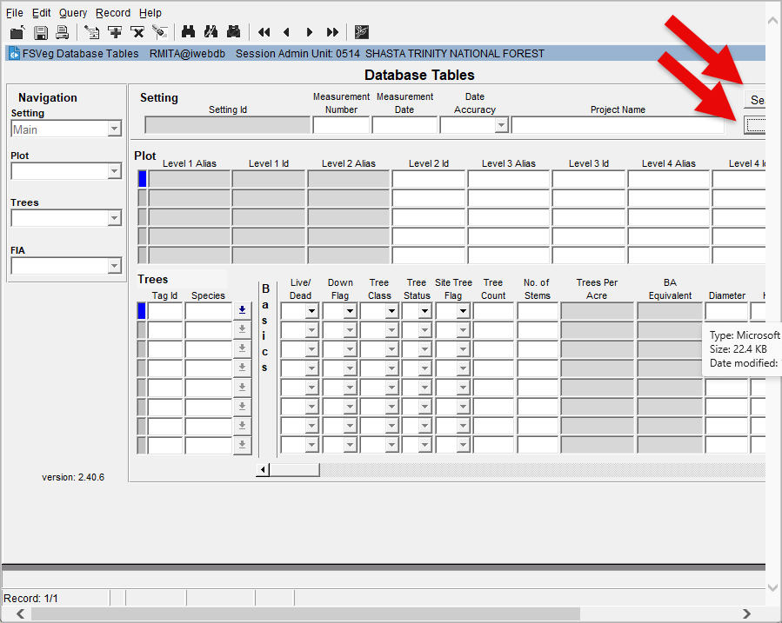

Appendix 5 Using Microsoft Excel to View FSVeg Spatial Data
Microsoft Excel can be used to view and query FSVeg Spatial data. This can be run in VDI or on the PC. Before querying, a connection will need to be created using an FS_PUBLIC_READ account. This role is automatically assigned to every user who has an NRM profile. If you use both PC and VDI, the following steps will need to be completed in each environment.
If Customized Queries have not been run in Excel before, follow the steps in Excel and Access Out of Memory Error Workaround to avoid a known bug. If only working on the PC, the fix doesn’t need to be done in VDI and vice versa.
Excel and Access Out of Memory link
Note
With an Office update, the Microsoft Query option was removed. The following steps bring the Microsoft Query option back into Excel.

Add Microsoft Query Option
- Open Microsoft Excel and select Blank workbook.
- On the File tab, select Options > Customize Ribbon.
- Choose All Commands in the Choose commands from: dropdown
- Scroll through the list and select From Other Sources [Get Data From…].
- On the right-hand side select New Group. Select the new group and rename it to whatever you want. Make sure it is under the Data section of the navigation tree.
- With the newly created group selected, click Add to move the From Other Sources [Get Data From…] into the new group.
- Click OK.
Customizing the Ribbon
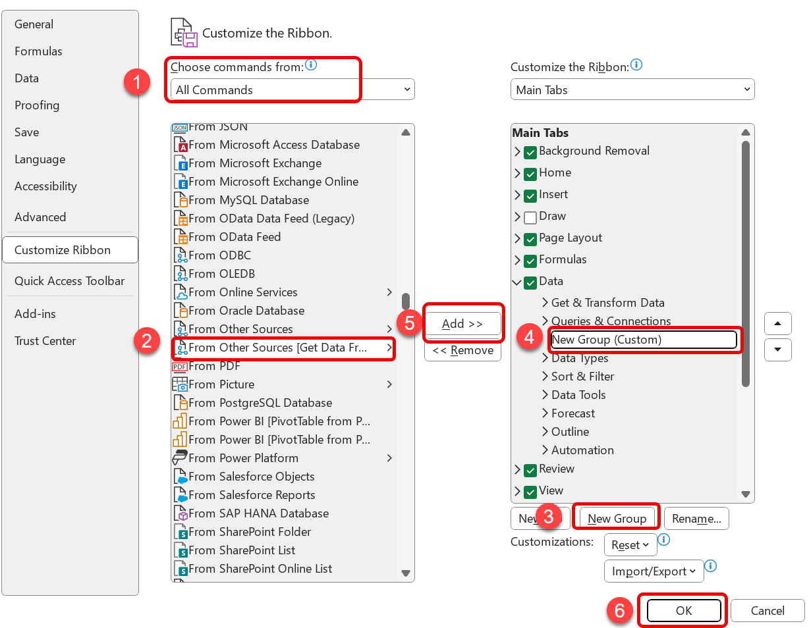

Create Connection
- Open Microsoft Excel and select Blank workbook.
- On the Data tab, select From Other Sources > From Microsoft Query.
Excel main menu, Data tab
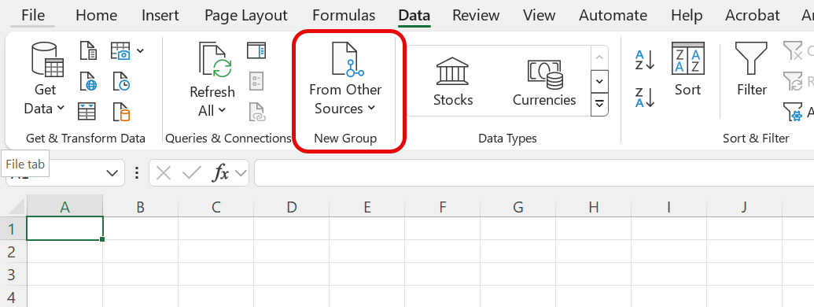

- On Choose Data Source screen select <New Data Source> and click OK.
Choose Data Source Window
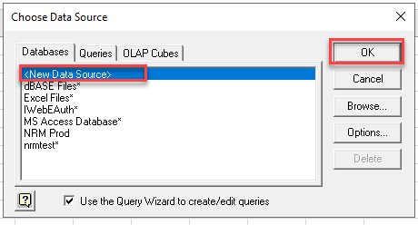
- Name the data source in Box 1 (you can name it whatever you want). In Box 2 select Oracle in OraClient19Home1 from the dropdown list. Click Connect.
Create New Data Source Window
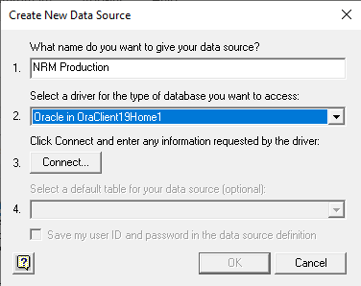
- Enter iwebdb in the Service Name and [fs_public_read] as user name. Leave the Password blank. Click OK.
Oracle ODBC Driver Connect Window
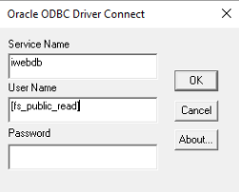

- Once the connecting to data source message goes away, checkmark the box next to Save my User ID… and select Yes on the pop up message. Click OK to close the Create New Data Source window.
Create New Data Source Window
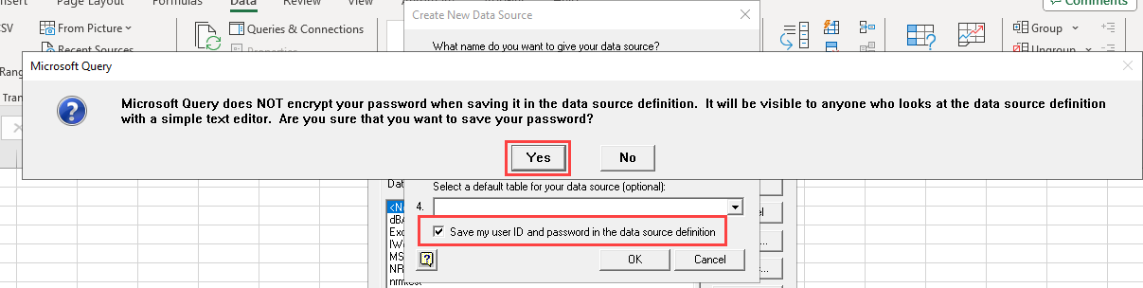
- The new connection is ready for use. These steps only need to be done once per data source.
Choose Data Source Window
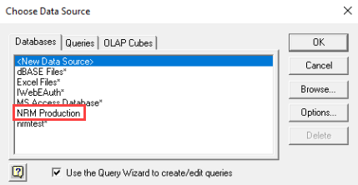

Creating a Customized Query in Excel

Starting Excel in VDI
- Open Edge and go to the VDI Login.
VDI link
- Log in with a valid USDA Domain username and password.
- Launch Microsoft Excel by clicking StartExcel. This opens an Excel spreadsheet.

Starting Excel on the PC
- Launch Microsoft Excel by clicking StartAll Programs Excel. This opens an Excel spreadsheet.

Note: The following steps are the same when working in VDI or on the PC.
- On the Data tab, select Get Data > From Other Sources > From Microsoft Query.
Excel main menu, Data tab
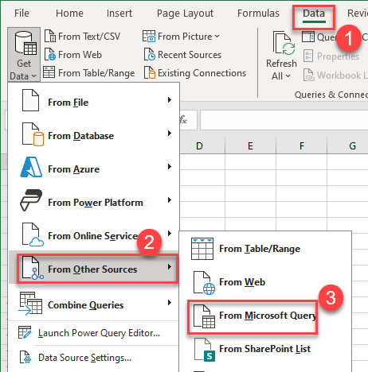
- The Choose Data Source window opens. Verify the Databases tab is active, select the connection you previously created and click OK.
Choose Data Source Window
- Once a connection is established, the Choose Columns window opens.
Choose Columns window
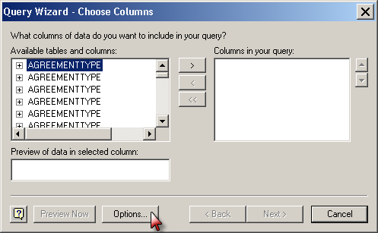
- Click Options.

- The Table Options form narrows the selection. Place a check in Views box, select a Forest from the LOV and click OK.
Table Options form
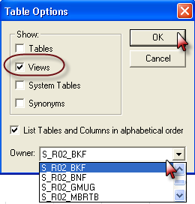

Example
The following example details the process of creating a query to join the attributes from two different tables. Stand identifier attributes must be selected from the NRIS_VEGPOLY_APRV for the query to identify the associated polygon(s).
Click on the plus to expand the available attributes for NRIS_VEGPOLY_APRV. Select the stand identifiers (e.g., SPATIAL_ID, SETTING_ID, REGION, FOREST, DISTRICT, etc.) from the attributes and use the arrows to move them to the Columns in the query section of the form.
Choose Columns window
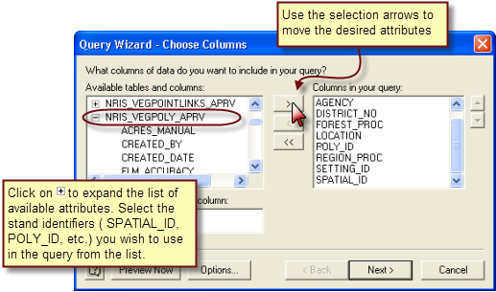

Select the attributes from another table(s) to join in the query. In the following example, NRIS_VEGCHARACTERIZATIONS is used.
Choose Columns window
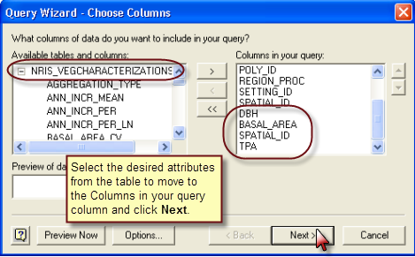
The following information window opens. This “error” occurs because Excel does not know how to join the tables, so they need to be joined manually.
MS Query dialog
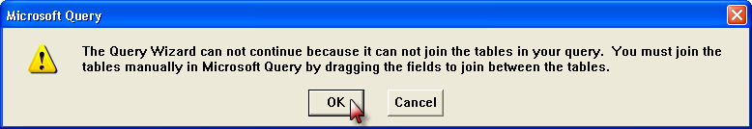
Click OK; the wizard discontinues and the Microsoft Query window opens.
In the Microsoft Query window, click on SPATIAL_ID in either table to highlight it. In the other table, scroll down until SPATIAL_ID is visible. While holding down the left mouse button, draw a line between the two SPATIAL _ID fields. The line between the two fields joins the two tables.
Microsoft Query window
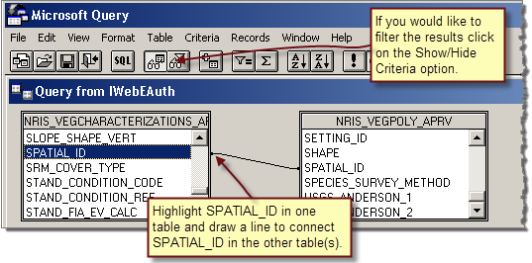

When the tables are joined go to File Return Data to Microsoft Office Excel.
File menu
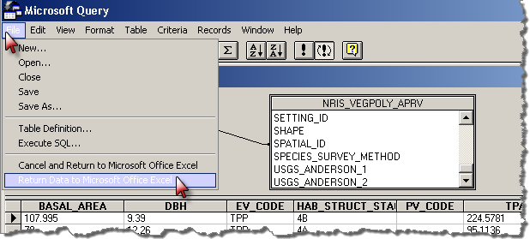
The Import Data form opens, click OK.
Import data dialog
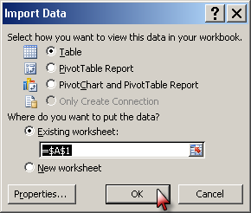
The query is exported to Excel.
Spreadsheet of exported data
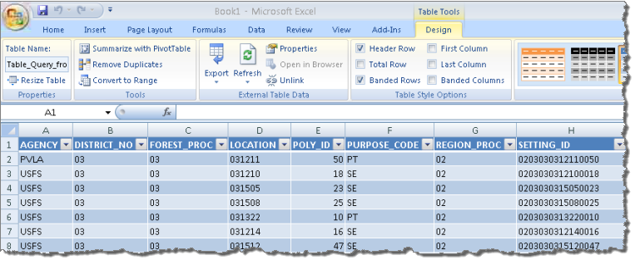

Creating a Pivot Table
To create a pivot table, click on Insert PivotTable.
Pivot Table
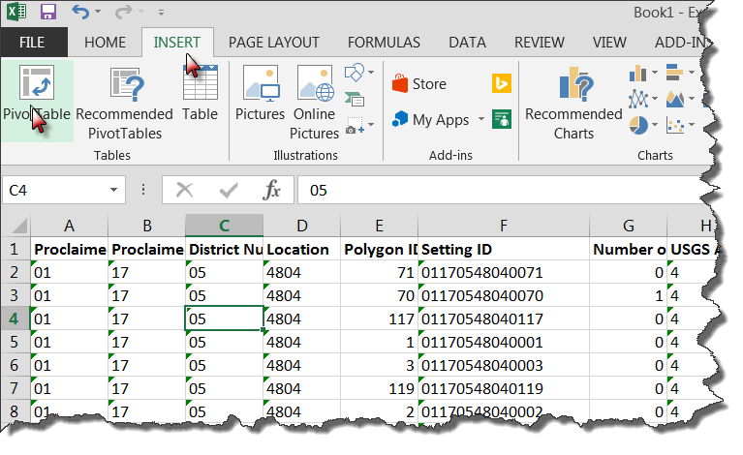
The Create PivotTable window opens. The data is automatically selected from the sheet. Keep the defaults and click OK.
Create PivotTable window
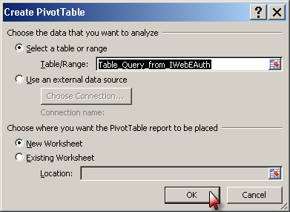

In the Pivot Table Field, check the desired fields in the Choose fields to add to report section on the right-hand side of the page. The Pivot Table on the left dis
Choose fields to add to report and summarize
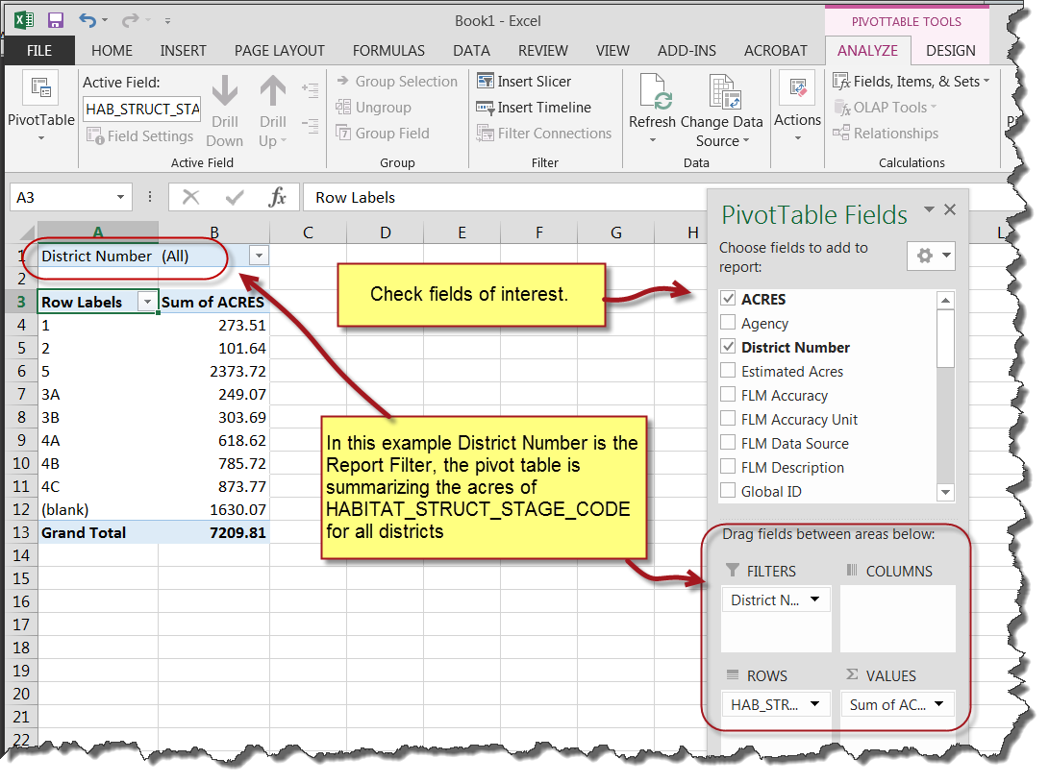
Filter the results by clicking on the filter option and selecting the desired option. In the following example, the results are filtered on DISTICT_NO 08.
Filter button
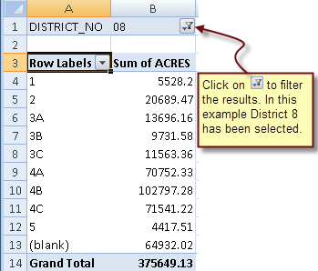

The attributes can be summarized in rows, columns or filtered by report. The following example shows the Habitat Structure Stage Code acres by district.
Habitat Structure Stage Code acres by district
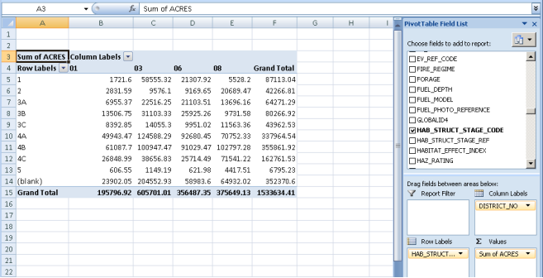
Multiple attributes can be listed in a row to aid in summarizing and displaying the data. The order the attributes are listed is important. In example below District is listed first, so by district, each HSS and its acres are listed.
Acres listed by District
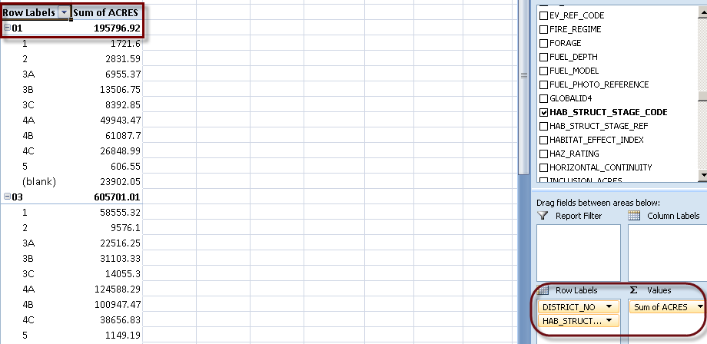

Listing HSS first, shows the number of acres of HSS on each district.
Acres of that HSS in each District
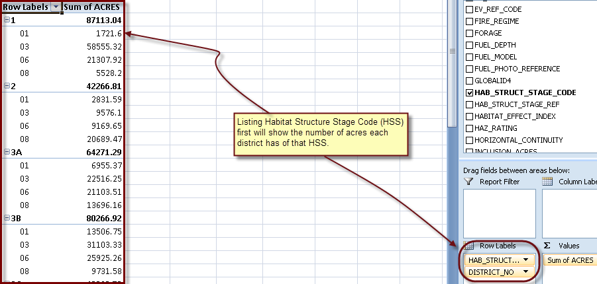

Click on Design Report Layout to select from the available options for viewing the information in the pivot Table.
Design tab, Report Layout
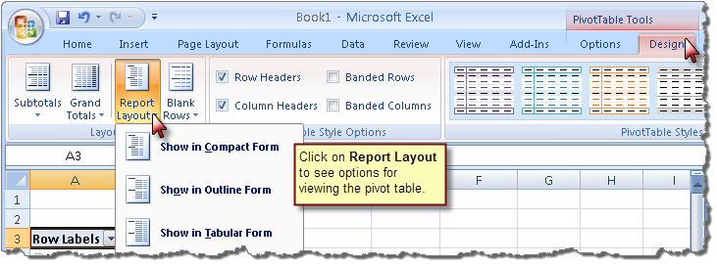

Saving the Customized Query
Before closing Excel, make the following changes to Save the Connection setup.
- Go to the Data tab, click Connections. In the Workbook Connections window, click Properties.
Workbook Connections
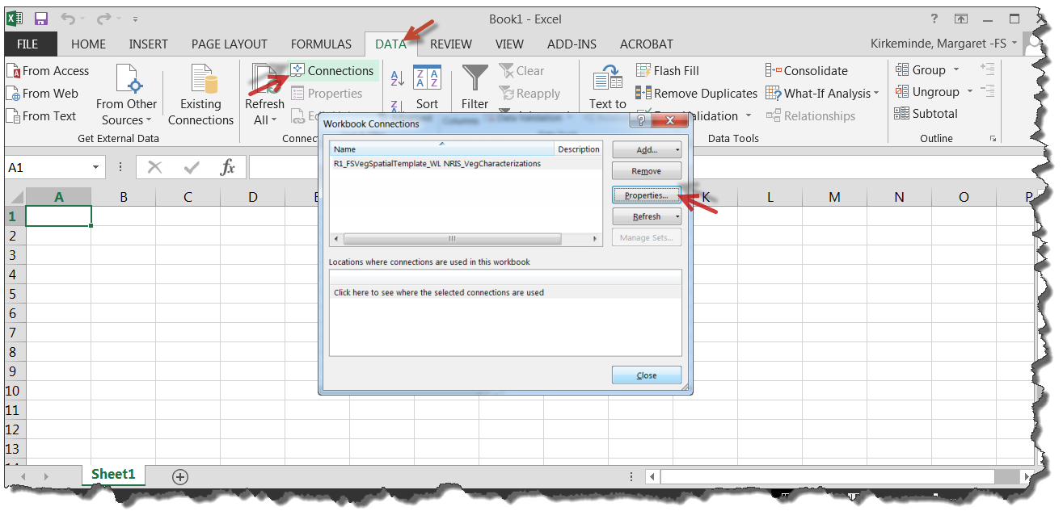
- Click the Definition tab in the Connection Properties window. Check the Save Password box. Click Yes, OK and Close.
Connection Properties window
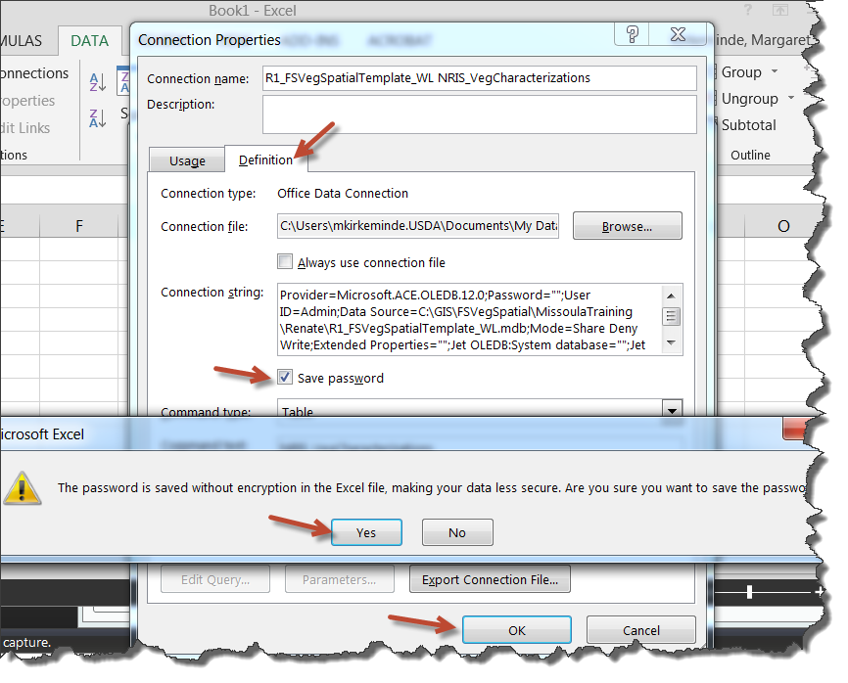

Appendix 6: Common Stand Exam (CSE) Field Techniques
1. Safety First (local units already have guidelines in place for all of these, so check with them)
A. Communications (radio/cellphone)
B. IN/OUT/ETR board + No-Return response plan
C. Driving
i. Dirt roads
ii. Oncoming (often logging traffic)
iii. Blind curves
iv. 4x4 use
v. Changing tires
vi. Parking and chock use
vii. Spotting
viii. Staying alert as the shotgun passenger
ix. Emergency gear (first aid kit, fire extinguisher, Pulaski, shovel)
x. Forest map
xi. Maintenance (checking fluids, tire pressures, etc.)
D. Death from above (snags/widowmakers)
E. Death from below (traction/stumps/staubs/vegetation/holes/cliffs/talus slopes/mine shafts/wet logs/stream crossings)
F. Weather
i. Heat
ii. Cold
iii. Lightning
iv. Precip/flooding
G. PPE – boots, hardhat, gloves, long clothing, plus a word about wearing jewelry in the woods
H. Biota hazards:
i. Plants
ii. Animals
I. Carry enough food and water for the day
J. Tailgate Safety Sessions
K. Encounters with the public
i. Stop to assist (see district policy)
ii. Safety first – Situational Awareness (and keep the Lost Hiker in your hip pocket)
iii. Forest map
iv. Polite and professional
v. If you don’t know, say so
vi. Know when you can and can’t provide transportation
vii. Use of the radio (can you relay messages for people, don’t transmit names, etc.)

2. Navigation
A. GPS
B. Map and Compass
i. Setting the declination: magnetic vs. true north
ii. Considerations of accuracy and error
iii. Walking in a straight line
a. Pick out a target in distance along compass line and walk to it
b. Crossing ridges, streams, any other disorienting topo feature
C. Distance
i. Pacing
ii. Pace Pole
3. The Underlying Philosophy of Stand Exams
A. Purpose:
i. Enable decisions for project-level analysis by collecting the data needed to address the relevant natural resource issues.
ii. Context and guidance: Forest Plan
a. Management Areas
b. Standards and Guides
c. Known Natural Resource Issues (more will surface during NEPA)
B. What’s a stand?
i. Relatively homogenous:
a. Vegetative Conditions:
1. Type
2. Size
3. Density
b. Physical Conditions (insolation/climate):
1. Slope
2. Aspect
3. Elevation
4. Soils
ii. The implications:
a. The entire stand will respond to a given treatment the same way.
b. This makes forestry predictable.
c. So stands are the fundamental building blocks of managing forest land!
d. Hey, that’s important.

4. Protocols and Intensity Levels:
A. Tree
i. 1 = Quick Plot
ii. 2 = Extensive
iii. 3 = Intensive
B. Vegetation Composition
i. 1 = Quick; Form 1 only
ii. 2 = TES, NOX, or Dominant 4; optional use of Forms 2, 3, 4
iii. 3 = All Species to a specified % cover; optional use of Forms 2, 3, 4
iv. 4 = All Species to a specified % cover, but certain species to trace cover; optional use of Forms 2, 3, 4
C. Surface Cover
D. Downed Woody
i. 1 = non-Brown’s
a. Photo Series
b. Fixed Radius Piece Count
ii. 2 = Brown’s Transect
5. Measurements
A. Setting
i. Slope - clinometer
ii. Aspect - compass
iii. Elevation – map/GPS
iv. Slope Position
B. Plot
i. Lat/long - GPS
ii. Capable Growing Area Percent
iii. Aspect - compass
iv. Slope - clinometer
v. Slope Position
vi. Slope Horizontal Shape
vii. Slope Vertical Shape
viii. Elevation
ix. EV Code – define existing veg (who is occupying the site?)
x. PV Code – define potential veg (who is going to occupy the site?)
xi. Fuel Model
xii. Residue Descriptive Code
xiii. Distance to Seed Wall
xiv. Plot History
xv. Plot History Date
xvi. Plot Remarks
xvii. User Code
Data Collection
1. Downed Woody
A. Brown’s
i. Go-no-go gauge + logger’s tape
ii. Transect length and height
iii. Size categories
1. 1-hour (0.01” to 0.24”): group tally
2. 10-hour (0.25” to 0.99”): group tally
3. 100-hour (1” to 2.99”): group tally
4. 1000-hour (3+”) each piece is its own record
iv. Tally rules
v. Need length to enable piece/acre estimates
vi. Other data:
1. 1st and 2nd Duff
2. Litter 1 and Litter 2
3. Piece Count
4. Decay Class
5. Intersection Diameter*
* Needed for computing pieces/acre
6. Diameter Large End
7. Diameter small End*
8. Piece Length*
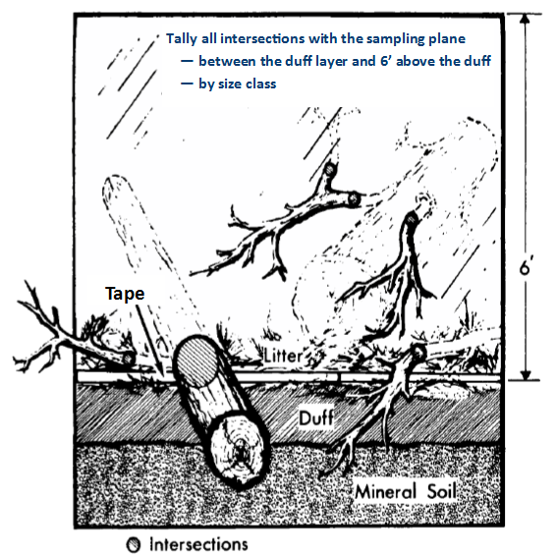

B. Other Protocols
i. Fixed-radius
ii. Photo series

2. Veg Composition
A. Three different protocols:
i. Cover by Lifeform
a. Tree
b. Shrub
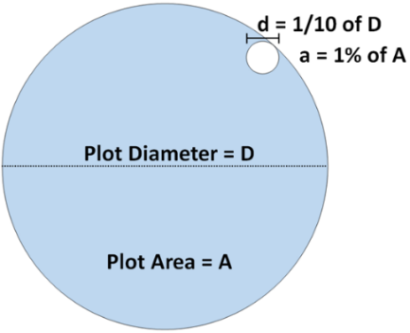
c. Forb
d. Graminoids
Note: Herbs = Forbs + Graminoids
ii. Cover by Species and Layer
a. Trees
b. Shrubs
iii. Cover by Species
B. Aids to estimating % canopy cover within a recorded class
i. It’s the canopy area projected onto the ground
ii. Don’t double-count the overlap between individuals in the same cover record
iii. Know the dimensions of a circle of 1% of the plot area:
iv. Yeah, it’s subjective
Plot | Plot Radius | 1% Area: Radius | Plot: Diameter | 1% Area: Diameter
1/10 ac | 37.2’ | 3.72’ | 74.47’ | 7.45’
1/100 ac | 11.78’ | 1.18’ | 23.55’ | 2.36’
1/300 ac | 6.80’ | 0.68’ | 13.60’ | 1.36’
C. Predominant Height
D. Predominant Diameter
E. Predominant Age
F. Maturity
G. Shrub Form Class
H. User Code
I. Remarks
3. Surface Cover
A. Aids to estimating % area
i. It’s the area at the plane of the ground surface intersected by the item
ii. For basal vegetation, this is a surprisingly small number! Even the densest rainforests have vegetation ground surface cover of about 15%.
B. Vegetation: Basal veg only, not canopy
C. Must add up to 100%
Remember: If eyeballing % cover is too subjective for your purposes, you can always use point transects instead. Lay out a 50- or 100-foot linear transect, then tally what is at every foot to obtain % cover.
A few words about sampling trees (because it can seem weird to normal people):
For efficiency, trees are separated into mutually exclusive, non-overlapping subpopulations:
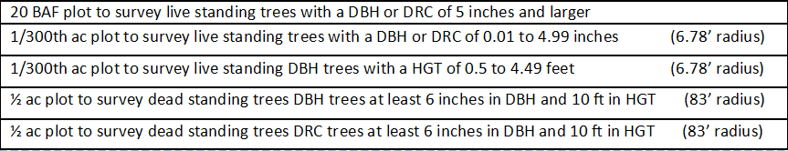
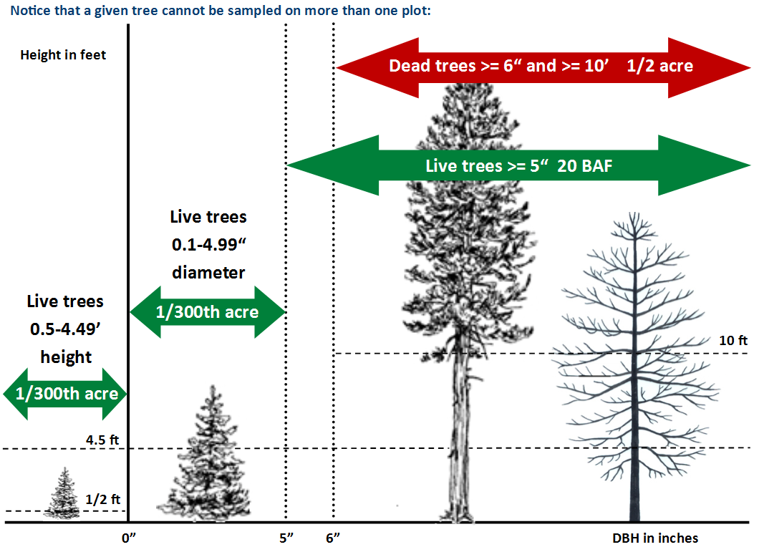

Back to Topic Y Bad Data Examples

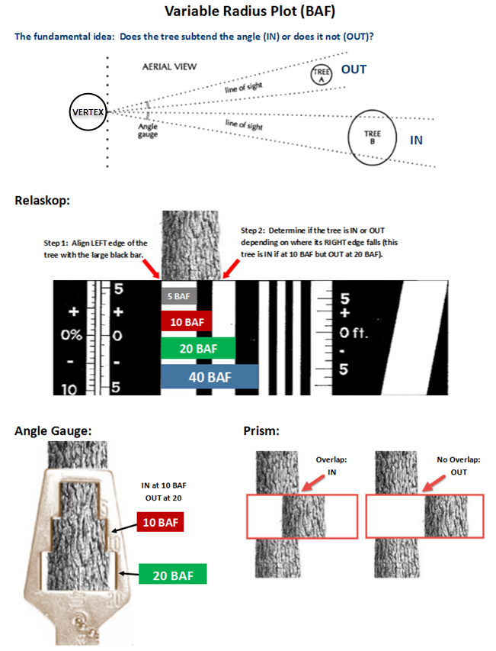
IMPORTANT: The vertex of a relaskop and angle gauge is your eye. The vertex of a prism is the prism.
4. Tree
A. Plot
i. Variable Radius
a. Methods
1. Relaskop
2. Prism
3. Angle Gauge
b. In/out determination by limiting distance from plot center to tree face at BH and percent slope of that line
ii. Fixed Radius
iii. In/out determination on slopes
B. Tag ID – start at north, proceed clockwise
C. Tree Status – live/dead/stump/down dead/down live
D. Tree Class – desirable/acceptable/etc.
E. Site/GST Tree
i. What are they
ii. When and how do you select them
iii. What additional measurements are needed
F. Species – taxonomic keys, local expertise
G. Tree Count (1 for most measured trees, > 1 for grouped tree tally)
H. DRC Number of Stems
i. Treat as one tree (one tree record on the form):
a. One crown
b. Stems clumped together
c. Effective diameter = square root of the sum of the squared diameters
ii. If only one stem at ground level = 1 stem
iii. Multiple stems at ground level = Number of stems
I. DBH or DRC
i. Use of the diameter tape under various bole conditions
J. Height (In feet for trees >= 4.5’, in feet and tenths for trees < 4.5’)
i. Methods
a. Logger’s tape + clinometer
b. Laser tools
ii. Most accurate with an accurate horizontal distance (same contour)
iii. Situations
a. Normal
b. Leaning
c. Forked below DBH
d. Forked above DBH
e. Forked with a broken top
f. Missing top (measure only what’s there)
g. In a tight clump of trees (kick it)
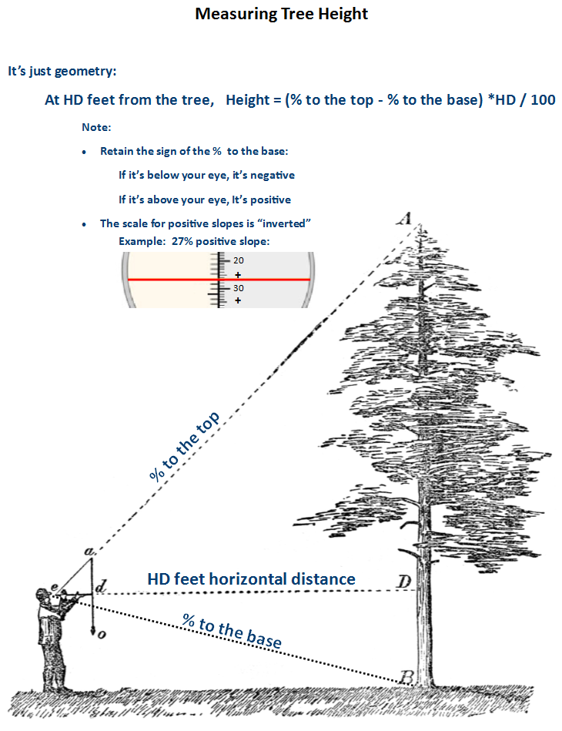
iv. Height to Crown – ground line to base of live crown
v. Radial Growth
a. Using the increment corer for growth: Position on the tree
1. At DBH
2. On the side facing plot center
b. Record in 20ths of an inch
vi. Radial Growth 2
vii. Height Growth
viii. Age
a. Total age for trees < 3” DBH
b. Age at DBH for trees >= 3 inches DBH
c. Using the increment corer for age:
1. Position on the tree – at DBH
2. Objective: hit the pith
3. Go only a little bit more than halfway
4. Insert core extractor (aka, “stinger”)
5. Back off ½ to 1 turn
6. Extract core
7. Read it – tricks:
• Orient so you’re looking through vascular tubes
• Moisten the near surface to increase light transmission
• Hold up to the sun
• Use a fine-tipped marker to mark every 10th ring
ix. Crown Ratio – live, uncompressed
x. Crown Class – relative position of the tree’s crown (dominant, codominant, etc.)
xi. Crown Width – average width of crown in feet
xii. Damages – consult local expertise to go over what signs and symptoms to look for in the region
a. Damage Category
b. Damage Agent
c. Damage Part
d. Damage Severity
xiii. Wildlife Use – local silviculturists would know what is of concern
xiv. Log/Snag Decay
a. Log Decay Classes
b. Snag Decay Classes
xv. Cone Serotiny
xvi. Remarks – local silviculturists could provide guidance as to what they would like to see here
xvii. User Code– local silviculturists could provide guidance as to what they would like to see here

Appendix 7: Contract Inspection

Appendix 8: Common Issues
❖ The FSVeg screen is truncated and I can’t see or use all the buttons.
To fix it, hold down the Ctrl key while scrolling the mouse wheel:
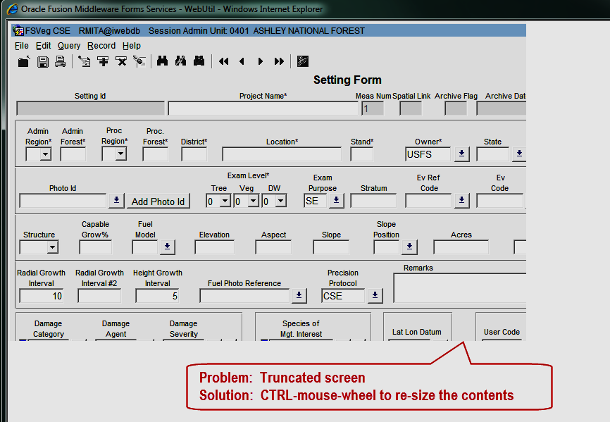
❖ Does anyone have a design for a go-no-go gauge for Brown’s Downed Woody Material surveys?
Here’s one from Fuel Load Sampling Method: “The gaps in the tool correspond to the 1-hour and 10-hour fuel sizes, and they allow quick assessment of fuel size. Make it out of sheet aluminum (about 0.06 inch thick) so that it is lightweight and durable. Or make one out of an old plastic card (such as the ones you get at grocery stores); while it won’t be as durable as an aluminum one, it is easier to make because you can cut the openings using scissors.” (Lutes, Duncan C. and Keane, Robert C. 2006. USDA Forest Service Gen. Tech. Rep. RMRS-GTR-164-CD).
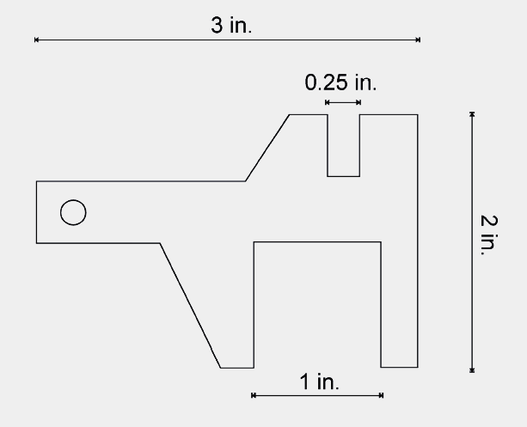
CSE Note:
The important measurements on the gauge are:
0.25” upper limit 1-hr,
lower limit 10-hr
1” upper limit 10-hr,
lower limit 100-hr
3” upper limit 100-hr,
lower limit 1000-hr

The 2” dimension isn’t used in the Brown’s protocol for CSE

This page intentionally left blank to place the ruler on an even page (avoids staples).



